Year 8 Assessment Task 1 2023
Modelling How the Body Works
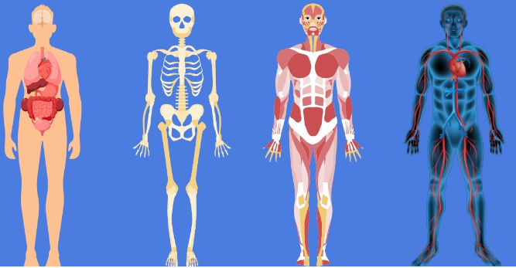
Select one of the following processes in the body and create a conceptual model to demonstrate:
- Circulatory System: How substances move in and out of cells
- Respiratory System: How the diaphragm inflates the lungs
- Digestive System: How stomach acid digests food
- Muscular/Skeletal System: How tendons make the hands grip
- Digestive System: How the oesophagus uses peristalsis to transport food
- Digestive system: How bile breaks down oils
- Or another that has been approved by your class teacher.

You will need to build this model at home, out of objects you may find around the house.
Part A - Plan and Construct your model
- Using this booklet, research, plan and sketch 2 designs of your model and then create a detailed final version for your construction. Include the height, length and width of your model. Your booklet will be handed in to your teacher by the due date.
- You will either photograph or video the model working. This file will need to be uploaded to CANVAS by the due date
Part B – Communicating your model. (Poster, powerpoint, prezi, etc)
- You will use a minimum of 3 images of your model of the key components of the process and annotate the images to explain what is occurring and why (Provide details of the key components being modelled.)
- You will also need to Analyse How well has the model demonstrated the biological process? (What are the strengths and weaknesses of the model)

Part A - Model Plan – (SC4 - 5WS)
Design
Equipment List

Notes on sourcing equipment
________________________________________________________________
________________________________________________________________
________________________________________________________________
________________________________________________________________
1st Design Idea
Notes:
________________________________________________________________
________________________________________________________________
________________________________________________________________
________________________________________________________________
________________________________________________________________
________________________________________________________________

Sketch one:

2nd Design Idea

Notes:
________________________________________________________________
________________________________________________________________
________________________________________________________________
________________________________________________________________
________________________________________________________________
________________________________________________________________
Sketch two:

Final Design Idea
Notes:
________________________________________________________________
________________________________________________________________
________________________________________________________________
________________________________________________________________
________________________________________________________________
________________________________________________________________
Final Design:

