Industrial Technology- Timber
Assessment Task Year 10
TOPIC: Side Table Design Task | MARKS: /20
SUBMISSION REQUIREMENTS:
This task is to be completed at home and submitted via CANVAS by Friday 26th May week 5, Term 2.

OUTCOMES TO BE ASSESSED:
IND5.2: applies design principles in the modification, development and production of projects
IND5.4: selects, justifies and uses a range of relevant and associated materials for specific applications
IND5.5: selects, interprets and applies a range of suitable communication techniques in the development, planning, production and presentation of ideas and projects

DIRECTIONAL VERBS:
Applies: Use, utilise, employ in a particular situation
Justify: Support an argument or conclusion.
Produce: Make or manufacture from components or raw materials.

TASK DESCRIPTION:
This task consists of THREE parts.

You are required to apply design principles to modify the image found in the assessment criteria of a tabletop.

- You will produce three modification ideas in the form of detailed labelled drawings.
- You are to select one of your modification ideas and complete the attached ALARM scaffold to justify the type of timbers that you will use.
- You will produce a timeline for your selected tabletop design which communicates when each step/process should be completed.

ASSESSMENT CRITERIA:

Part A-
You are to produce three different tabletop designs. Each design must include the following:
- Labelled species of timber to be used
- A variety of unique pattern ideas for the tabletop (widening joints)
- Communication of ideas must be neat with evidence of using a ruler and pencil

Part B-
You are to complete the attached ALARM scaffold to justify the timber species selected and the final design idea.

Part C-
You will produce a five week timeline that communicates your production sequence for the construction phase of your completed table top design. A scaffold is attached to this task. For each week in your timeline you must explicitly state when you will complete the following processes:
- The dimensions of your tabletop (overall length and width)
- The size and number of your timber panels
- Accurately mark each piece of timber for cutting
- Cut timber panels
- Mark joinery techniques chosen
- Execute joinery techniques
- Finishing techniques on the tabletop

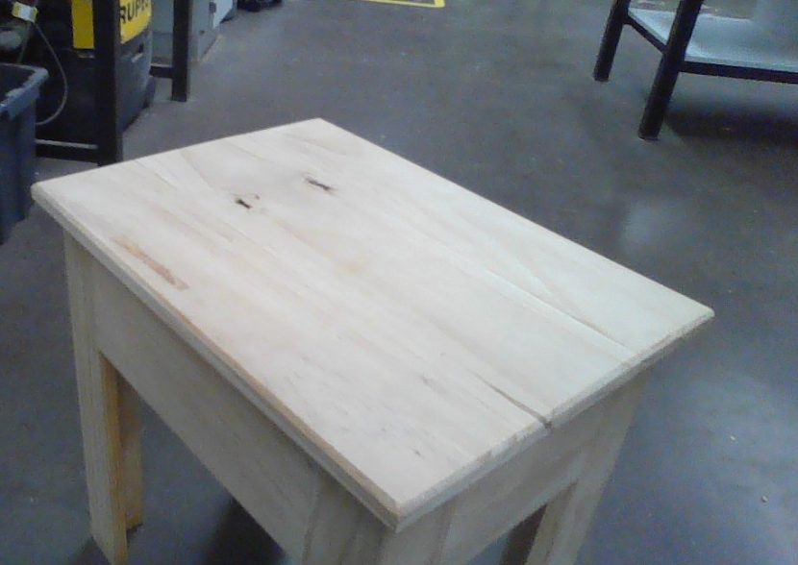

ASSESSMENT MARKING CRITERIA
IND5.2: applies design principles in the modification, development and production of projects | Mark | Grade
A student applies to an outstanding level the design principles in the modification, development and production of projects by completing three tabletop designs which include all of the following:  - Accurate and correctly labelled species of timber to be used  - A unique and aesthetic pattern idea for the widening joints for each tabletop design  - Clear and detailed communication of ideas, accurately and neatly drawn, with evidence of using a ruler and pencil | 5 | A
A student applies to a high level the design principles in the modification, development and production of projects by completing three tabletop designs which include all of the following:  - Correct labelling of species of timber to be used  - An aesthetic pattern idea for the widening joints for each tabletop design  - Clear communication of ideas, relatively accurately drawn, with evidence of using a ruler and pencil | 4 | B
A student applies to a sound level the design principles in the modification, development and production of projects by completing at least two tabletop designs which include most all of the following:  - labelling of species of timber to be used  - A pattern idea for the widening joints for each tabletop design  - Communication of ideas, relatively accurately drawn, with evidence of using a ruler and pencil | 3 | C
A student applies to a basic level the design principles in the modification, development and production of projects by completing at least two tabletop designs which may or may not include the following:  - Attempt at labelling of species of timber to be used  - A basic pattern idea for the widening joints for each tabletop design  - Some communication of ideas. May/ may not show evidence of using a ruler and pencil | 2 | D
A student applies to a limited level the design principles in the modification, development or production of projects by completing at least one tabletop designs which may or may not include some of the following:  - Attempt at labelling the species of timber to be used  - A limited and incomplete drawing of a tabletop design  - May/ may not show evidence of using a ruler and pencil | 1 | E

IND5.4: selects, justifies and uses a range of relevant and associated materials for specific applications | Mark | Grade
A student selects, justifies and uses a range of relevant and associated materials for specific applications at an outstanding level through the inclusion of the following:  - Accurate and clear justification as to what extent the timber species satisfies the aesthetic appeal of the final table design  - A thorough and detailed ALARM scaffold | 9-10 | A
A student selects, justifies and uses a range of relevant and associated materials for specific applications at a high level through the inclusion of the following:  - A clear justification as to what extent the timber species satisfies the aesthetic appeal of the final table design  - A detailed ALARM scaffold | 7-8 | B
A student selects, justifies and uses a range of relevant and associated materials for specific applications at a sound level through the inclusion of most of the following:  - Justification as to what extent the timber species satisfies the aesthetic appeal of the final table design  - An adequate ALARM scaffold | 5-6 | C
A student selects, justifies and uses a range of relevant and associated materials for specific applications at a basic level through the inclusion of some of the following:  - Brief notes as to what extent the timber species satisfies the aesthetic appeal of the final table design  - A basic attempt at using the ALARM scaffold | 3-4 | D
A student selects, justifies and uses a limited range of relevant and associated materials for specific applications at limited level by providing a comment on how the timber species satisfies the aesthetic appeal of the final table design | 1-2 | E

IND5.5: selects, interprets and applies a range of suitable communication techniques in the development, planning, production and presentation of ideas and projects | Mark | Grade
A student selects, interprets and applies a range of suitable communication techniques to an outstanding level in the development, planning, production and presentation of ideas and projects by developing a 5 week timeline which clearly stipulates the following:  - A clear, realistic and accurate understanding of the time it takes to complete each component of the process of developing a tabletop  - All seven steps are clearly communicated within the timeline | 5 | A
A student selects, interprets and applies a range of suitable communication techniques to a high level in the development, planning, production and presentation of ideas and projects by developing a 5 week timeline which attempts to stipulate the following:  - A clear understanding of the time it takes to complete each component of the process of developing a tabletop  - Most of the seven steps are clearly communicated within the timeline | 4 | B
A student selects, interprets and applies a range of suitable communication techniques to a sound level in the development, planning, production and presentation of ideas and projects by developing a timeline which includes the following:  - A satisfactory attempt at developing a timeline with some understanding of the time it takes to complete each component of the process of developing a tabletop  - At least five of the seven steps are clearly communicated within the timeline | 3 | C
A student selects, interprets and applies a range of suitable communication techniques to a basic level in the development, planning, production and presentation of ideas and projects by developing a timeline which may/may not include both of the following:  - A basic attempt at developing a timeline which may/may not show an understanding of the time it takes to complete each component of the process of developing a tabletop  - At least three of the seven steps are clearly communicated within the timeline | 2 | D
A student selects, interprets and applies a limited range of suitable communication techniques to a limited level in the development, planning, production and presentation of ideas and projects by developing a timeline which appears hastily attempted and not thought through with at least one of the seven steps mentioned | 1 | E

Year 10 Industrial Technology Timber – Assessment Task 2
Outcome IND 5.4
Question:
1. Justify the timber species to be used in your tabletop design.

Identify | Describe | Explain | Analyse | Critically Analyse | Evaluate
List/identify the timber species. | What does the timber species look like? | What is the purpose of using this particular species of timber? | How do the characteristics of the timber species influence the final design? | How / why are the characteristics of the timber species more positive and/or negative than the others? | To what extent does the timber species satisfy the aesthetic appeal of the final table design?

Timeline Scaffold

Week | Processes
1

2

3

4

5

