Stage 5 Support English
Culture Kitchen Assessment Task 2023
TOPIC: Culture Kitchen | MARKS: Total /20
SUBMISSION REQUIREMENTS:
Students are to submit their discursive piece as a linked Google Document or attached Word Document to CANVAS on Friday 16th June, 2023 (Week 8) by 8.30am.
Failure to submit the task by the scheduled date and time will result in a mark of zero being recorded and an ‘N’ Award warning letter issued.
Applications for Illness/Misadventure must be completed using the appropriate form from the Assessment Handbook, accompanied with supporting third-party documentation (e.g. a doctor’s certificate).
Students who do not submit the task on the required date and time must submit the task on the next day that they attend school, unless prior arrangements have been made.
A maximum of 2 drafts per student may be submitted prior to the assessment task due date. No feedback will be provided after Friday 9th of June 2022.

OUTCOMES TO BE ASSESSED:
EN5-1A responds to and composes increasingly sophisticated and sustained texts for understanding, interpretation, critical analysis, imaginative expression and pleasure
EN5-7D Understands and evaluates the diverse ways texts can represent personal and public worlds.
EN5-8D Questions, challenges and evaluates cultural assumptions in texts and their effects on meaning.

DIRECTIONAL VERBS:
Demonstrate (through composing and responding): Show by example through composition and response
Develop (through understanding) : To grow/improve and advance in quality through developed understanding
Critically (Evaluate): Make judgement based on criteria; to determine value

TASK DESCRIPTION:

Context: AusCulture is an Australian magazine that explores aspects relating to Australian culture and identity. Through the discussion of both contemporary and historical issues in Australian society, we seek to better understand what it is that makes Australia the nation it is today.

Students are required to demonstrate a developed understanding of the Culture Kitchen module by composing a discursive text for AusCulture magazine which critically evaluates and addresses the following question:

What does it mean to be a modern Australian?

Develop a position and critically evaluate the question with reference to ONE text studied in class and ONE of your choosing (You can choose a text studied in class or one of your own choosing- A test of your own choosing must be teacher approved)

Your discursive piece should be NO more than 800 words.

ASSESSMENT CRITERIA:

In composing your discursive text, you should address the following:

- Demonstrate an understanding of the Culture Kitchen module – where you develop a position in relation to the question that covers your perspective on what it means to be a modern Australian. In your discussion you might make comparisons between ‘clichéd’ representations of Australia as indicative of a bogan, meat-pie eating and drinking culture and consider how Australians generally differ from this perspective by:
  - Being a global citizen, or more recently, with the advent of COVID-19, taking an isolationist standpoint.
  - Acknowledging the significance of our first nation’s peoples
  - Feeling a connection to landscape
  - Recognising stoicism (personal strength) and/or community spirit e.g. fires, floods.

Note: You are NOT limited by the above representations of Australians.

- When critically evaluating your perspective you should:
  - Acknowledge and provide differing perspectives from the text studied during class time and one of your own choosing, which ultimately leads to a judgement. The reader should be aware of your position in a clear, reflective and/or evaluative resolution. This is irrespective of your response being more open-ended or explicitly concluding your perspective on the question.
  - Provide detailed supporting evidence, which includes direct quotes as appropriate.

- In addition to the above, your developed position and critical evaluation should be made with the appropriate form and features of a discursive text, which may include but not be limited to:
  - A relevant title
  - Personal, first-person perspective
  - Inclusion of anecdotes
  - Emotive, reflective, descriptive and connotative language
  - High-modality language
  - Linking words to help convey perspective
  - Appropriate use of statistics
  - Rhetorical questions
  - Humour

Note: Your discursive piece should be NO more than 800 words.

- An example structure and approach to starting your discursive piece can be found on the next two pages. You are NOT limited to this structure.

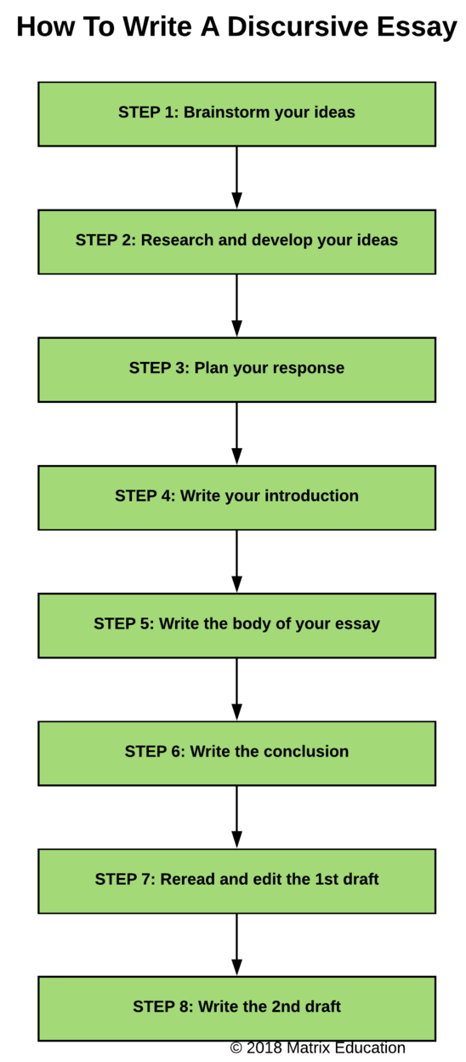

Culture Kitchen Discursive Text Scaffold
Question: What does it mean to be a modern Australian?
Introduction  Outline multiple perspectives in response to the question | _____________________________________________________________________________________________  _____________________________________________________________________________________________  _____________________________________________________________________________________________  _____________________________________________________________________________________________  _____________________________________________________________________________________________  _____________________________________________________________________________________________  _____________________________________________________________________________________________
Paragraph 1  Expand on the details of your topic | _____________________________________________________________________________________________  _____________________________________________________________________________________________  _____________________________________________________________________________________________  _____________________________________________________________________________________________  _____________________________________________________________________________________________  _____________________________________________________________________________________________  _____________________________________________________________________________________________  _____________________________________________________________________________________________
Paragraph 2  Present first perspective on topic | _____________________________________________________________________________________________  _____________________________________________________________________________________________  _____________________________________________________________________________________________  _____________________________________________________________________________________________  _____________________________________________________________________________________________  _____________________________________________________________________________________________  _____________________________________________________________________________________________  _____________________________________________________________________________________________
Paragraph 3  Present an alternative perspective on the topic | _____________________________________________________________________________________________  _____________________________________________________________________________________________  _____________________________________________________________________________________________  _____________________________________________________________________________________________  _____________________________________________________________________________________________  _____________________________________________________________________________________________  _____________________________________________________________________________________________  _____________________________________________________________________________________________
Paragraph 4  An anecdote that reflects your perspective on the topic | _____________________________________________________________________________________________  _____________________________________________________________________________________________  _____________________________________________________________________________________________  _____________________________________________________________________________________________  _____________________________________________________________________________________________  _____________________________________________________________________________________________  _____________________________________________________________________________________________  ______________________________________________________________________________________________
Conclusion  Write a concluding statement | ______________________________________________________________________________________________  ______________________________________________________________________________________________  ______________________________________________________________________________________________  ______________________________________________________________________________________________  ______________________________________________________________________________________________  ______________________________________________________________________________________________  ______________________________________________________________________________________________  _______________________________________________________________________________________________

ASSESSMENT MARKING CRITERIA | Mark | Grade
Composes a skilful discursive text that critically evaluates what it means to be a modern Australian. In doing so the student will provide a balance of personal observations with different perspectives using a highly engaging, creative and relevant opening statement. This will be supported by a detailed exploration of ideas which clearly suggests a position or point of view, whilst demonstrating sustained paragraphing with strong topic sentences, developed explanation and detailed supporting evidence and /or anecdotes with a resolution that may be reflective or open ended. The student will skilfully use discursive language forms and features, appropriate to the audience and purpose that includes, but may not be limited to, the effective use of first-person perspective, emotive, subjective and descriptive language, humour, rhetorical questions, connotative language and linking phrases. The student will also be consistent in the correct use of spelling, punctuation and grammar conventions. A strong personal voice will be clearly sustained throughout the response. | 17-20 | A
Composes an effective discursive text that critically evaluates what it means to be a modern Australian. In doing so the student will provide a balance of personal observations with different perspectives using a highly engaging, creative and relevant opening statement. This will be supported by a detailed exploration of ideas which suggests a position or point of view, whilst demonstrating sustained paragraphing with strong topic sentences, developed explanation and detailed supporting evidence and /or anecdotes with a resolution that may be reflective or open ended. The student will skilfully use discursive language forms and features, appropriate to the audience and purpose that includes, but may not be limited to, the effective use of first-person perspective, emotive, subjective and descriptive language, humour, rhetorical questions, connotative language and linking phrases. The student will also be consistent in the correct use of spelling, punctuation and grammar conventions. A strong personal voice will be evident but some aspects of the response may lack detail and/or depth. | 13-16 | B
Composes a discursive text that evaluates what it means to be a modern Australian. In doing so the student will attempt to provide a balance of personal observations with different perspectives using a creative and relevant opening statement. This will be supported by an exploration of ideas presented which may suggest a position or point of view, whilst demonstrating sustained paragraphing with topic sentences, developed explanation and supporting evidence and /or anecdotes with a resolution that may be reflective or open ended. The student will use discursive language forms and features, appropriate to the audience and purpose that includes, but may not be limited to, the effective use of first-person perspective, emotive, subjective and descriptive language, humour, rhetorical questions, connotative language and linking phrases. The student will also be consistent in the correct use of spelling, punctuation and grammar conventions. There is evidence of personal voice through the use of discursive techniques and structure, although this may not be sustained. | 9-12 | C
Composes a discursive text that attempts to evaluate what it means to be a modern Australian. In doing so the student will to provide personal observations with at least one different perspective using an opening statement, limited exploration of ideas presented which may suggest a position or point of view. There will be some evidence of paragraphing, explanation, supporting evidence and a resolution. The student will be inconsistent with their use of discursive language forms and features such as first-person perspective, emotive, subjective and descriptive language, humour, rhetorical questions, connotative language and linking phrases. The student will also be consistent in the correct use of spelling, punctuation and grammar conventions. There may be evidence of personal voice through the use of discursive techniques and structure, although this may not be sustained. | 5-8 | D
Makes some attempt to compose a discursive text about what it means to be a modern Australian. In doing so the student will to provide a basic exploration of ideas presented. There will be little. If any, evidence of paragraphing, explanation, supporting evidence and a resolution. The student will be very limited with their use of discursive language forms and features such as first-person perspective, emotive, subjective and descriptive language, humour, rhetorical questions, connotative language and linking phrases. The student will also be very consistent in the correct use of spelling, punctuation and grammar conventions. There will be no evidence of personal voice due to the lack of discursive techniques and structure. | 1-4 | E
Name: Total: /20

