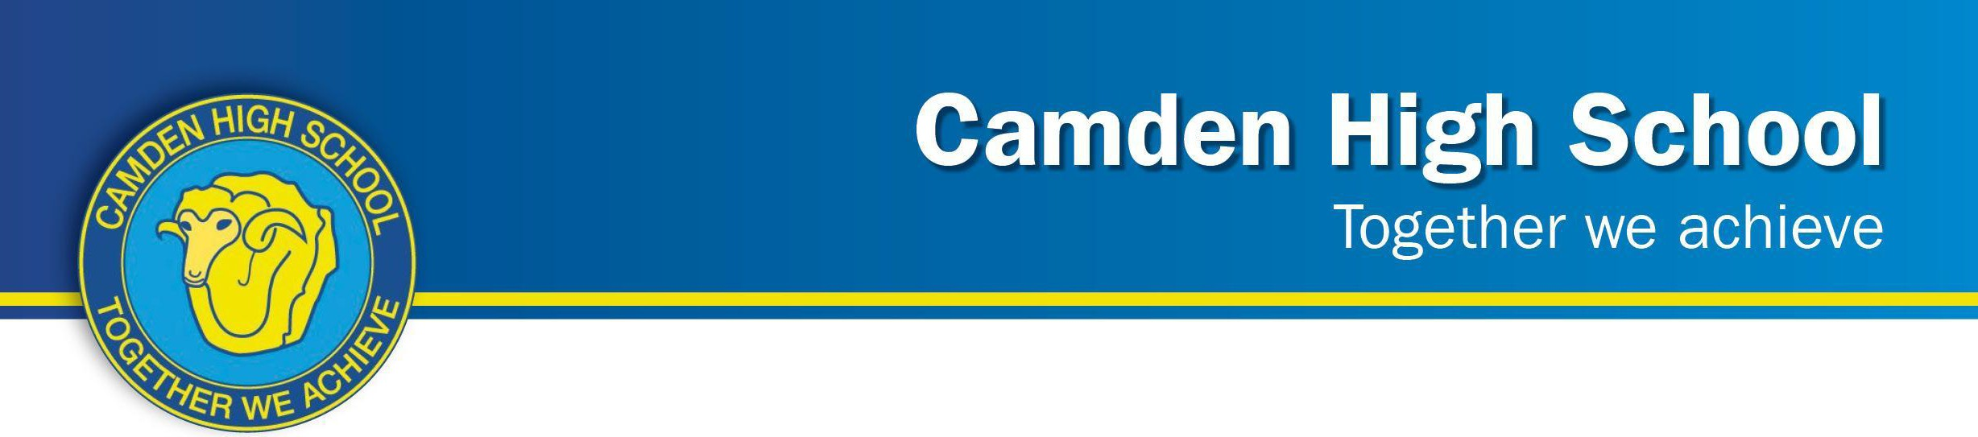

Year 8 Science

First Hand Investigation 2023

|  |  |
| --- | --- |
| **TOPIC**: CW2 Chemical Changes: First Hand Investigation | **MARKS:** / **30** |
| **SUBMISSION REQUIREMENTS:**  Students will undergo a First-Hand investigation during  ***Term 2, Week 8***  **8SCI_B – *Tuesday 13th June 2023 Period 4***  ***8SCI_O – Wednesday 14th June 2023 Period 2***  ***8SCI_G – Wednesday 14th June 2023 Period 3***  ***8SCI_Y – Wednesday 14th June 2023 Period 5***  ***8SCI_R – Friday 16th June 2023 Period 2***  ***8SCI_I – Friday 16th June 2023 Period 4*** |
| **Outcomes to be assessed:**  **SC4 - 4WS** - **Identifies** questions and problems that can be tested or researched and makes predictions based on scientific knowledge.  **SC4 – 5WS** -Collaboratively and individually produces a plan to **investigate** questions and problems.  **SC4 – 6WS** - **Follows** a sequence of instructions to safely undertake a range of **investigation** types, collaboratively and individually.  **SC4 – 7WS** - Processes and **analyses** data from a first-hand investigation and secondary sources to identify trends, patterns and relationships and draw conclusions.  **SC4 – 8WS** -Selects and uses appropriate strategies, understanding and skills to **produce** creative and plausible solutions to identified problems.  **SC4 – 17CW** - **Explains** how scientific understanding of, and discoveries about the properties of elements, compounds and mixtures relate to their uses in everyday life. | |
| **DIRECTIONAL VERBS:**  **Analyse**: Identify components and the relationship between them; draw out and relate implications  **Explain**: Relate cause and effect; make the relationships between things evident; provide why and/or the ;how.  **Identify**: Recognise and name  **Investigate**: Plan, inquire into and draw conclusions about  **Produce**: Make or manufacture | |
| **TASK DESCRIPTION:** Students will engage in a first-hand **investigation** focused on physical and chemical changes. The assessment will involve **following** a sequence of instructions and **analysing data** related to these changes. Students are required to **explain** the concepts behind these changes and their significance in scientific contexts. Additionally, students will be challenged to think creatively and **produce** plausible solutions to identified problems related to chemical and physical changes. **Duration: 1 hour**  Extensive feedback will be provided to students upon the return of the completed assessment. | |

**ASSESSMENT CRITERIA**

You will need to apply your knowledge of chemical and physical reactions in a laboratory setting by **following** a sequence of instructions and performing chemical testing on various substances safely.

You will need to be able to **analyse** the data to **identify** if a change you see is a chemical change or a physical change by applying the signs of physical and chemical changes accurately.

You should **explain** the signs of a chemical reaction and understand how to tell whether a chemical change or a physical change is taking place.

You should also ensure you understand all the laboratory safety rules and can conduct testing by yourself safely.