Year 10 STAR Science

Assessment Task 2025

|  |
| --- |
|  |

|  |  |
| --- | --- |
| **TOPIC**: Physical World: Electricity | **WEIGHTING:**  30%  **COMPONENTS:** |
| **SUBMISSION REQUIREMENTS:**  **Due Term 1 Week 10. Friday 4th April, 2025**  This task will be submitted by 3pm on the due date.  Part one will be submitted on this paper with answers and diagrams completed in the space provided.  Part two will be a submission of the completed constructed circuit made in class. |
| **TASK Description**  In Science this term you have been learning about the physical world. In this task you will be assessed on your practical skills and your knowledge around circuits and circuits diagrams. In both the practical and written components of the assessment task you will be expected to display your knowledge of circuits.  **You will be expected to plan, design and produce an electrical circuit.**  Archie Comics Sabrina The Teenage Witch Platform Shoes Comic Womens T-Shirt  | Tiny house plans, House floor plans, Floor plan layout  **Part One: House Plans**  You are an electrician who must rough in the electrical for a new house. The architect didn’t create a plan for the electrical, so it is up to you to design the circuits for this house.  You must use the house plans provided to draw correct circuit diagrams throughout the house. The client has requested the following in their house:   * A light in every bedroom * A light in each of the bathroom kitchen and hallway * Two lights in the dining room * Three lights in the great room   A skilled electrician knows that:   * Only one light switch per room * All lights must be wired in parallel circuits apart from the great room which must be series. * The bedrooms and bathroom must be on a separate circuit to the rest.   **Part Two: Circuit Design**  You are to build a mini electrical circuit model of the great room as per your house diagram.  You will be given:   * Wires * 9Volt Battery * Battery clip * 3 light globes | |
| **OUTCOMES TO BE ASSESSED:**  SC5-9WS - Presents science ideas and evidence for a particular purpose and to a specific audience, using appropriate scientific language, conventions and representations | |
| **DIRECTIONAL VERBS:**  **Presents:** show or offer (something) for others to consider | |

**Part One – Design the Circuit Diagram for the House**

1. How many Lights are needed to complete the job, and how many switches are needed?

Lights ______________ Switches ____________

1. Label over the House plan below where you would put each light and switch to meet the requirements in the task description.

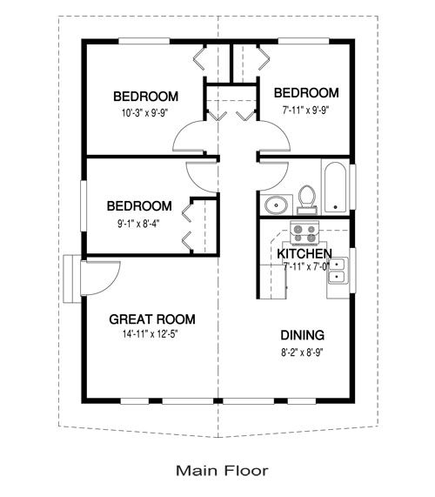

1. Draw (ruler and pencil/pen) a circuit diagram of the house circuit as per the task description, ensuring that all electrical requirements are met. Use a full page to do this and ensure it is neat and that the circuit symbols are correct. You can draw this below or on separate paper and submit with the task.

Hint. There should be two circuits.

**Part Two – Build a Circuit**

You are to build a mini electrical circuit model of the great room as per your house diagram. Just one single circuit that could supply the three lights required in this room.

You will be given:

* + - 15x15cm piece of wood
    - 50cm of Wire
    - 9Volt Battery
    - Battery clip
    - 3 LED lights

1. On the 15cm grid below draw an accurate circuit diagram for the great room circuit you are going to make.

You will be marked on how appropriate your plan is and how well your final product matches the plan below.

Consider things like

* light placement
* wire lengths

1. BUILD YOUR CIRCUIT – This will be a step by step process in class, with each step demonstrated by the teacher. This will involve accurately building and connecting the components of the circuit. Then using hot a glue gun in place of solder to both secure connections and also secure circuit to the wood. Then lastly holes will be drilled in the wood to insert globes so that one side of the wood will be the circuit and the other will have the lights.
2. Once your project is complete. Evaluate the process by answering the questions below, explaining what problems you discovered and how you overcame them.

What are some challenges you encountered while designing and building your house circuit?

____________________________________________________________________________________________________________________________________________________________________________________________________________________________________________________________________________________________________________________________________________________________________________________________

How did you solve these problems?

____________________________________________________________________________________________________________________________________________________________________________________________________________________________________________________________________________________________________________________________________________________________________________________________

If you solved the problem, what advice would you give to others?

_____________________________________________________________________________________________________________________________________________________________________________________________________________________________________________________________________________________________

If you did not solve the problem, what do you think a good next step would be?

____________________________________________________________________________________________________________________________________________________________________________________________________________________________________________________________________________________________________________________________________________________________________________________________

If you had to give your final project (circuit) a mark out of 10, what would you give it and why?

____________________________________________________________________________________________________________________________________________________________________________________________________________________________________________________________________________________________________________________________________________________________________________________________

|  |  |
| --- | --- |
| PART ONE  **ASSESSMENT MARKING CRITERIA** | |
| Part one and Part two will contribute evenly | **Grade** |
| * Identified the correct number of lights and switches and labelled house diagram accurately with extremely well thought out light and switch placement. * The labelling of the house plan demonstrates a thorough level of understanding of the components in a circuit. * An outstanding circuit diagram is created which reflects extensive knowledge and understanding of electrical flow and circuits. | A |
| * Identified the correct number of lights and switches and labelled house diagram accurately with well thought out light and switch placement. * The labelling of the house plan demonstrates a high level of understanding of the components in a circuit. * A well executed circuit diagram is created which reflects a high level of knowledge and understanding of electrical flow and circuits. | B |
| * Identified the correct number of lights and switches and labelled house diagram accurately with well thought out light and switch placement. * The labelling of the house plan demonstrates a sound level of understanding of the components in a circuit. * A suitable circuit diagram is created which reflects a sound level of knowledge and understanding of electrical flow and circuits. | C |
| * Identified some of the lights and switches required and attempted to label the house diagram with suitable light and switch placement. * The labelling of the house plan demonstrates a basic level of understanding of the components in a circuit. * A circuit diagram is created which reflects a basic level of knowledge and understanding of electrical flow and circuits. | D |
| * Inaccurately identified the number of lights and switches required and made a limited attempt to label the house diagram with light and switch placement. * The labelling of the house plan demonstrates a limited level of understanding of the components in a circuit. * A circuit diagram is attempted which reflects a limited level of knowledge and understanding of electrical flow and circuits. | E |

**FEEDBACK: GRADE: RANK:**

|  |  |  |
| --- | --- | --- |
| PART TWO  **ASSESSMENT MARKING CRITERIA** | | |
| Part one and Part two will contribute evenly and be work 15marks each. | **Mark** | **Grade** |
| * Circuit diagram for the great room is executed extremely well, and light placement and wire length shows a thorough understanding of electrical circuit creation. * An outstanding working circuit is created which followed all steps precisely and accurately, and the final product is of an extremely high standard. * Barriers encountered during circuit design and construction is thoroughly evaluated and the self-evaluation is insightful and well thought out. | 13-15 | A |
| * Circuit diagram for the great room is executed well, and light placement and wire length shows a high level of understanding of electrical circuit creation. * A highly effective working circuit is created which followed all steps precisely and accurately, and the final product is of a high standard. * Barriers encountered during circuit design and construction is evaluated and the self-evaluation is insightful and well thought out. | 10-12 | B |
| * Circuit diagram for the great room is appropriate, and light placement and wire length shows a good level of understanding of electrical circuit creation. * A working circuit is created which followed all steps at a suitable level, and the final product is of a sound standard. * Barriers encountered during circuit design and construction is identified and the self-evaluation is completed. | 7-9 | C |
| * Circuit diagram for the great room is attempted, and light placement and wire length shows a basic level of understanding of electrical circuit creation. * A circuit is created which followed most of the steps, and the final product is of a basic standard. * Barriers encountered during circuit design and construction, and the self-evaluation are attempted, but not in depth. | 4-6 | D |
| * Circuit diagram for the great room is attempted, and light placement and wire length shows a limited level of understanding of electrical circuit creation. * A circuit is attempted, and the final product is of a limited standard. * Barriers encountered during circuit design and construction, and the self-evaluation is minimal in insightfulness or depth. | 0-3 | E |

**FEEDBACK: MARK: GRADE: RANK:**