|  |  |
| --- | --- |
| **TOPIC**: Plant Production: Effect of Light on Plant Growth | **MARKS:** /45 |
| **SUBMISSION REQUIREMENTS:**  All components to be submitted **ONLINE** through **CANVAS** by **11.59pm on Friday 13th December 2022** (Week 9 Term 4) | **WEIGHTING:**  20% |
| **OUTCOMES TO BE ASSESSED:**  H1.1 **Explains** the influence of the physical, biological, social, historical and economic factors on sustainable agricultural production  H2.1 **Describes** the inputs, processes and interactions of plant production systems  H4.1 **Justifies** and **applies** appropriate experimental techniques, technologies, research by methods and data presentation and analysis in relation to agricultural problems and situations | |
| **DIRECTIONAL VERBS:**   |  |  | | --- | --- | | **Applies**  **Describes**  **Explains** | Use, utilise, employ in a particular situation  Provides characteristics and features  Relate cause and effect; make the relationships between things evident; provide why and/or how | | **Justifies** | Support an argument or conclusion | | |
| **TASK DESCRIPTION:**  **Part A Experimental Design (H4.1) (30 marks)**  Students are to **apply** and **justify** an experimental design that investigates the effects of light on the growth of plants. Students are expected to conduct a Firsthand Investigation using experimental design principle, **analyse** the results, and present their findings as a written experimental report.  **Part B Research (H2.1) (5 marks)**  Students are to **describe** the inputs, processes, interactions and feedback of a plant production system. Students are to use the Floristry Industry as their plant production system and use one of the system models discussed in class.  **Part C Sustainable Agricultural Production (H1.1) (10 marks)**  Students are to **explain** the physical and social factors that influence sustainable agricultural production. | |
| **ASSESSMENT CRITERIA**  **PART A – EXPERIMENTAL DESIGN AND REPORT (30 Marks)**  Students are to conduct a Firsthand investigation to determine if the source of light has an impact on the growth of plants utilising plants provided by the school. The principles of experimentation including standardisation, control, replication and randomisation, will be applied to this task.  Students are expected to design and carry out a First-Hand Investigation, analyse results obtained, and present results as a written experimental report.  There are several scenarios’ students can choose to investigate:   * Scenario A: light vs no light for plant growth * Scenario B: does light affect direction of plant growth * Scenario C: effect of different colours of light on plant growth * Scenario D: effect of different light intensities on plant growth   Students are to perform the experiment at home. The school will provide some equipment as outlined below, however, the student must organise a light source (the sun should be fine for most experiments or lamps) and a growing medium.  **EQUIPMENT PROVIDED**:   * Seedlings * Pots or small trays * Other equipment may be available on request.   Students are to record results over a minimum of four (4) week period recording data that is applicable to their specific investigation. Criteria may include but not limited to:   * Height of plants * Colouring of leaves * Number of leaves * Number of flowers   Photographs and/or diagrams are to be used to support results. Students must plan their First-Hand Investigation carefully so that they have **measurable data**.  ***Your Task***  After conducting the experiment, students are required to produce a written report using ONE (1) of the scenarios provided that is based on the following points:   * *Research**question (Aim)* * *Hypothesis* * *Equipment* * *Method*: Steps to perform task. Include a diagram or photos of the experiment set up * *Experimental Design Principles***:** **describe** how were each of these principles met: standardisation, control, replication, and randomisation * *Results***:** Tabulated data to be used to determine averages for each set of data for each day of analysis.Graphical representation is also required of the tabulated data * *Data* ***Analysis****:* What did the results indicate? **Describe** any trends or patterns with the data. * *Discussion***:**    + Scenario A: **Explain** why light is essential for plant growth and how the amount of direct light available impacts on that growth – use examples to support your response.   + Scenario B: **Explain** why light is essential for plant growth and how the direction of the light source impacts on that growth – use examples to support your response.   + Scenario C: **Explain** why light is essential for plant growth and how the different colour of light (light wavelength) impacts on that growth – use examples to support your response.   + Scenario D: **Explain** why light is essential for plant growth and how the intensity of the light source impacts on that growth – use examples to support your response.   **Describe** any potential problems (at least two) that may have occurred when conducting the experiment and how they can be overcome. **Describe** two improvements that could be considered if this experiment were to be performed again.   * *Conclusion*   **PART B – RESEARCH (5 MARKS)**   * **Describe** the inputs, processes, outputs, boundaries, and feedback of a plant production system. Students are to use the Floristry Industry as their plant production system and use one of the system models discussed in class.   Examples of farming system models are provided to assist the students in undertaking this section.  **PART C – SUSTAINABLE AGRICULTURAL PRODUCTION (10 MARKS)**   * **Explain** the influence of the physical and social factors on sustainable agricultural production? Students are to complete the attached ALARM matrix to collate their information **AND** write an exposition. | |

|  |  |  |
| --- | --- | --- |
| **Part A: Experimental Design and Report H4.1** | **Mark** | **Grade** |
| Develops a comprehensive experimental report that demonstrates an extensive investigation on the impact of fertiliser on the germination and growth rate of pastures. The aim, hypothesis, method and appropriate data are included and in the correct format. The basic principles of experimental design are extensively applied. All data is **justified** effectively and evaluated to provide two (2) valid improvements to the experimental design. The conclusions either do or do not support the hypothesis with extensive justification. | 25-30 | A |
| Develops a thorough experimental report that demonstrates a thorough investigation on the impact of fertiliser on the germination and growth rate of pastures. The aim, hypothesis, method and appropriate data are included and in the correct format, although some details may be lacking. The basic principles of experimental design are all addressed with some inconsistencies. All data is **explained** effectively, to provide two (2) valid improvements to the experimental design. The subsequent conclusions either do or do not support the hypothesis with student justification present. | 19-24 | B |
| Develops a sound experimental report that demonstrates a sound investigation on the impact of fertiliser on the germination and growth rate of pastures. The aim, hypothesis, method, appropriate data, and principles of experimental design are included and in the correct format, although some components may be incomplete or incorrect. Collected data is **described** with an attempt to provide two (2) valid improvements. The subsequent conclusions either do or do not support the hypothesis. | 12-18 | C |
| Develops a basic experimental report that demonstrates a basic investigation on the impact of fertiliser on the germination and growth rate of pastures. The aim, hypothesis, method, appropriate data, and principles of experimental design are included and in correct format, with several components incomplete or incorrect. Collected data is displayed, a valid improvement attempted and a conclusion that either does or does not support the hypothesis. | 6-11 | D |
| There is evidence of a limited experimental report that demonstrates a limited investigation of pastures. The aspects of experimental design have been attempted but lack details in relation to relevance, correct format or conclusions drawn. | 1-5 | E |

**Year 12 Agriculture**

**Assessment Task 1, 2024**

|  |  |
| --- | --- |
| **Part B: Research** **H2.1** | **Marks** |
| * Comprehensively **describes** all aspects of a farming systems model of the Floristry Production enterprise | 5 |
| * Effectively **describes** most aspects of a farming systems model of the Floristry Production enterprise | 4 |
| * Soundly **describes** several aspects of a farming systems model for a Floristry Production enterprise | 3 |
| * Basically **describes** a component of a farming systems model for a Floristry Production enterprise | 2 |
| * Identifies an aspect of a farming systems model for a Floristry production enterprise | 1 |

|  |  |
| --- | --- |
| **Part C: Sustainable Agricultural Production H1.1** | **Mark** |
| **A comprehensive exposition will demonstrate all of the following:**   * A logical and highly detailed **explanation** of **at least 2** physical AND social factors that influence sustainable agricultural production. * Information presented in an appropriate style required. * Information piece satisfies the presentation brief with correct spelling, punctuation and grammar. | 9-10 |
| **An extensive exposition will demonstrate all of the following:**   * A logical and less detailed **explanation** of **at least 2** physical AND social factors that influence sustainable agricultural production. * Information presented in an appropriate style required. * Information piece satisfies the presentation brief with mostly correct spelling, punctuation and grammar. | 8-7 |
| **A sound exposition will demonstrate all of the following:**   * A logical and detailed **description** of **one** physical AND social factors that influence sustainable agricultural production. * Information presented in an appropriate style. * Information piece satisfies the presentation brief with mostly correct spelling, punctuation and grammar. | 6-5 |
| **A basic exposition will demonstrate the following:**   * **Identification** of aphysical OR social factor that influence sustainable agricultural production. * Information presented * Information piece attempts to satisfy the presentation brief * There are spelling and/or punctuation and/or grammatical inaccuracies. | 4-3 |
| **A limited exposition will demonstrate;**   * A relevant statement is provided that outlinesfactors that influence sustainable agricultural production | 2-1 |

**Part A: Experimental Design**

**HSC Agriculture: First-Hand Investigation *Template***

|  |  |
| --- | --- |
| **Research Question** |  |
| **Hypothesis** |  |
| **Equipment** |  |
| **Methodology** |  |
| **Experimental Design Principals** | Replication  Randomisation  Standardisation  Control |
| **RESULTS** | Tabulated and graph |
| **DISCUSSION** |  |
| **CONCLUSION** |  |

**Part B: Research – Systems Models**

Below are examples of systems models that are used for farming enterprises. Students are to use these as a reference for the agricultural enterprise of Floristry Production to produce an appropriate systems model.

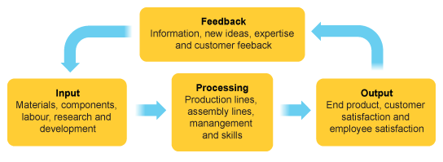

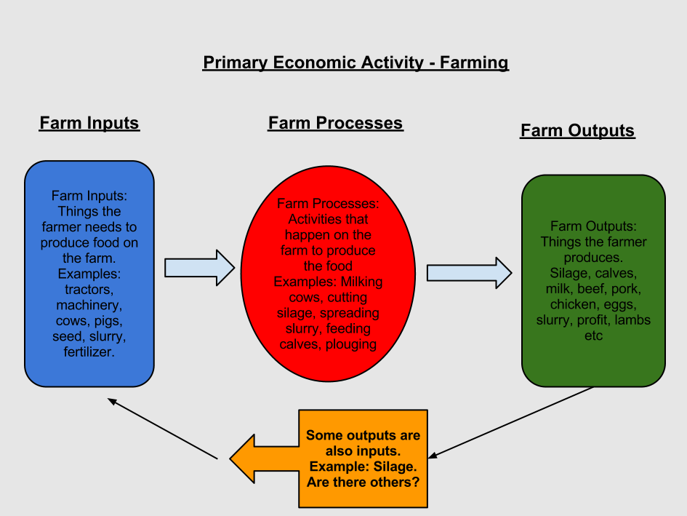

Feedback

**Part C: SUSTAINABLE AGRICULTURAL PRODUCTION (10 MARKS)**

**Inquiry Question:** **Explain** the influence of the physical and social factors on sustainable agricultural production?

|  |  |  |  |  |
| --- | --- | --- | --- | --- |
| **Identify** | **Describe** | **Explain** | **Analyse** | **Evaluate** |
| **Identify the factors for sustainable agriculture** | **Describe the features/components for each factor towards agricultural production** | **Farmers regularly make decisions on resources for short and long term sustainable production. What is the purpose of these decisions?** |  |  |
| **Physical** |  |  |  |  |
| **Social** |  |  |  |  |

**Written Exposition** (10 marks)

Utilising the ALARM matrix, **explain** the influence of the physical and social factors on sustainable agricultural production.

________________________________________________________________________________________________________________________________________________________________________________________________________________________________________________________________________________________________________________________________________________________________________________________________________________________________________________________________________________________________________________________________________________________________________________________________________________________________________________________________________________________________________________________________________________________________________________________________________________________________________________________________________________________________________________________________________________________________________________________________________________________________________________________________________________________________________________________________________________________________________________________________________________________________________________________________________________________________________________________________________________________________________

________________________________________________________________________________________________________________________________________________________________________________________________________________________________________________________________________________________________________________________________________________________________________________________________________________________________________________________________________________________________________________________________________________________________________________________________________________________________________________________________________________________________________________________________________________________________________________________________________________________________________________________________________________________________________________________________________________________________________________________________________________________________________________________________________________________________________________________________________________________________________________________________________________________________________________________________________________________________________________________________________________________________________________________________________________________________________________________________________________________________________________________________________________________________________________________________________________________________________________________________________________________________________________________________________