Physical Fitness
Year 9 Physical Activities and Sports Studies
2024

TOPIC: Fitness Fanatics | MARKS: 30
SUBMISSION REQUIREMENTS:  Friday 22nd March 2024 (Week 8) via CANVAS | WEIGHTING: 25%
OUTCOMES TO BE ASSESSED:
5-8 Displays management and planning skills to achieve personal and group goals
5-10 Analyses and appraises information, opinions and observations to inform physical activity and sport decisions
DIRECTIONAL VERBS:
Displays – The arrangement and choice of type in a style intended to show evidence
Analyses – Identify components and the relationship between them; draw out and relate implications
Plan – a detailed proposal for doing or achieving something
Appraise - assess the values/quality of
TASK DESCRIPTION:

There are two parts to the assessment task that you need to complete:

Part A: (10 Marks)
Using the Fitness testing results collected during practical lessons, you are to create a table that clearly and accurately displays all fitness testing results, appraising the results to average scores for Male and Females of their age group.

Part B: (20 Marks)
Students are to analyse results to inform areas of strength and weakness that have been highlighted in the fitness results table and plan a 4-week training program to improve fitness testing results. This program should use SMART goals and link to the areas of need and improvement. The program is to be specific to their sport of choice. Students should concentrate on components of fitness that are most related to that sport.

ASSESSMENT CRITERIA:
You will be assessed on your ability to:
- Participate in health and skill related components of fitness testing during their theory / practical lessons
- Record testing results into their fitness work booklet during these lessons
- Accurately collated fitness testing results and data into a table
- Analyse results compared to norms to identify areas of strength and weakness – Download and use the Fitness Test App (see attachment to assist with access).
- Plan 4-week training program using SMART goals targeted at areas of improvement for a chosen sport

ASSESSMENT MARKING CRITERIA – Part A
5-8 Displays management and planning skills to achieve personal and group goals | Mark | Grade
Displays an extensive table of fitness testing results. The student clearly displays each fitness testing result in a table, appraising the results to average score for Male and Females of their age group. | 9-10 | A
Displays a comprehensive table of fitness testing results. The student displays each fitness testing result in a table, appraising the results to average score for Male and Females of their age group. Although some aspects of the table are incomplete or incorrect. | 7-8 | B
Displays a sound table of their fitness testing results. The student displays most fitness testing result in a table, appraising most of their results to average score for Male and Females of their age group. Although minor aspects of the table are incomplete or incorrect. | 6-5 | C
Displays a basic table of their fitness testing results. The student displays some fitness testing results in a table, appraising some of their results to average score for Male and Females of their age group. Although many aspects of the table are incomplete or incorrect. | 3-4 | D
Displays a limited table of fitness testing results. The student displays a few fitness testing results in a table, attempting to appraising a few of their results to average score for Male and Females of their age group. Although most aspects of the table are incomplete or incorrect. | 1-2 | E
Task not attempted | 0 | N

Feedback: ________________________________________________________________________________________________________________________________________________________________________________________________________________________________________________________________________________________________________________________________________________________________________________________________________________________________________________________________________________________________________________________________

Feedback: ________________________________________________________________________________________________________________________________________________________________________________________________________________________________________________________________________________________________________________________________________________________________________________________________________________________________________________________________________________________________________________________________

ASSESSMENT MARKING CRITERIA – Part B
5-8 Displays management and planning skills to achieve personal and group goals  5-10 Analyses and Appraises information, opinions and observations to inform physical activity and sport decisions | Mark | Grade
Outstanding analysis of their fitness testing results to inform the planning of a training program for a specific sport. The student extensively outlines their areas of strength and areas of improvement with their testing results, plans a detailed 4-week training program using SMART goals to assist in improving their areas of weakness. | 18-20 | A
Thorough analysis of their fitness testing results to inform the planning of a training program for a specific sport. The student clearly outlines their areas of strength and areas of improvement with their testing results, plans an in-depth 4-week training program using SMART goals to assist in improving their areas of weakness. Although some aspects of analysis or design are incorrect/ incomplete. | 14-17 | B
Sound analysis of their fitness testing results to inform the planning of a training program for a specific sport. The student outlines most of their areas of strength and improvement with their testing results, plans a 4-week training program using some aspects of the SMART principle to plan goals to assist in improving their areas of weakness. Although some aspects of analysis or design are incorrect/ incomplete. | 10-13 | C
Basic analysis of their fitness testing results to inform the planning of a training program for a specific sport. The student identifies some of their areas of strengths and improvement with their testing results, plans a training program using few aspects of the SMART principle to plan goals to assist in improving areas of weakness. Although many aspects of analysis or design are incorrect/ incomplete. | 6-9 | D
Limited analysis of their fitness testing results to inform the planning of a training program for a specific sport. The student identifies a few areas of strengths and improvement with their testing results, attempts to plan a training program but fails to link it to their areas of weakness. Although most aspects of analysis or design are incorrect/ incomplete. | 1-5 | E
Task not attempted | 0 | N

Accessing the Fitness Norms – How to guide

To access the testing norms, download the ‘Fitness Tests’ App on your phone.
Click on each of the Health and Skill Related Tests that you completed in class.
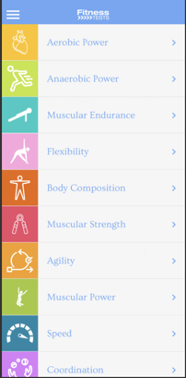
Then click on the specific test that you completed.
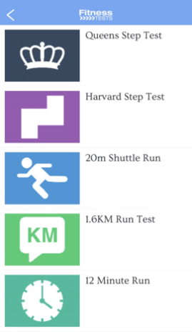
At the end of each test instruction is the tests norms. Click on it and open it up (Circled in picture).
