Year 8 Mathematics
Assessment Task 1 - 2024

Take Home Assignment

NAME:
CLASS:
TEACHER:

Year 7 Mathematics
Assessment Task 1 - 2024

TOPICS: Financial Mathematics and Volume | MARKS: 65
SUBMISSION REQUIREMENTS:
Term 1 – Week 7 - In Class – Thursday 14th March (8C,8K) Friday (8B, 8G, 8M,8N,8W,8Y)
OUTCOMES TO BE ASSESSED:
MA4-1WM Communicates and connects mathematical ideas using appropriate terminology, diagrams, and symbols.
MA4-5NA Operates with fractions, decimals, and percentages.
MA4-6NA Solves financial problems involving purchasing goods.
DIRECTIONAL VERBS:
Communicate – use visual and written representation.
Operate – calculate a value.
Solve – answer a math problem.
Use – apply in a particular situation.
Connects – associate or relate.
TASK DESCRIPTION:
Section 1 – DUELLING DISCOUNTS / 18
- You are required to take photos of three items including their price when you go shopping. The items should be over $20.
- Using your photos of items, complete the table by finding both 30% off and $30 off for each item.
- Using information from the table completed, you are to illustrate the best option with an example.
Section 2 – ADVERTISMENTS / 7
- You are to correctly calculate the discounts and check for any errors.
- You are to paste a picture of an item which has a percentage discount on it. There is an example provided to assist you.
- Using the picture of your item, solve the worded problem, showing necessary working out.
Section 3 – GROCERY LIST AND GST /23
- You are to paste a screen shot of an ingredient for the pasta from the Coles website.
- You are required to complete the table, showing working out for the GST charged for each ingredient.
- a) You are to show all necessary working out to support your answer.
- Present the findings of the question using some evidence.
Section 4 – CONVERSIONS /17
- You are to correctly fill out the decimal, fractions and percentages table.
- You are to complete the conversions table

Section 1 – Duelling Discounts

You and your family decide to purchase some goods and go shopping on the weekend to see what bargains are available. There are two discount options available, $30 OFF or 30% OFF (shown in the picture below). Your family doesn’t know which discount option to use. Your job is to help them decide which the better option.

$ 30 OFF
PART 1: (3marks)
You are to go shopping and take a picture of three products that you wish to purchase including their price tag. Paste the three pictures which you have taken on the space provided below. To assist you, two pictures have already been supplied as a guide. Examples of products can be HD TV, Nike shoes, coffee table, toys, PS5, cooking utensils, fridge, and clothes. All products must cost over $20 and at least 1 over the $100, 1 below $100 and 1 product of your choice.

AVENGERS PLAYSET FLATSCREEN TV

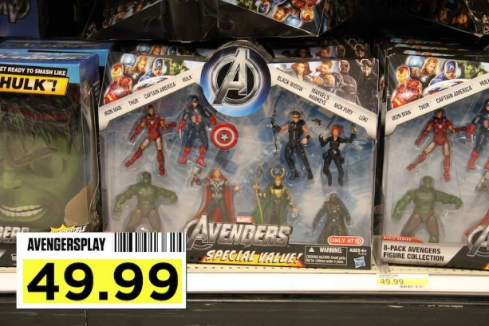
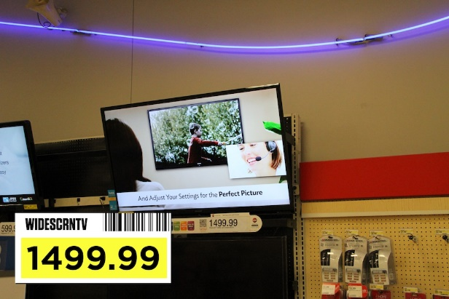

PRODUCT 1: (1 mark)
(worth over $100)

PRODUCT 2: (1 mark)
(worth between $20 and $100)

PRODUCT 3: (1 mark)
(choose your own, worth over $20)

PART 2: (12 marks)

Using the products which you have purchased, complete the table below, showing working out for both vouchers, $30 off and 30% off. The first row has been done for you as a guide.

ITEM | COST | $30 OFF | 30% OFF | Which is better?
The Avengers playset | $49.99 | 49.99 – 30 = $19.99 | 100% - 30% = 70%  49.99 × 0.70 = $34.99 | $30 OFF by $15.
Widescreen TV  This row will be completed with your class teacher. | $1499.99
Product 1 over $100.

Product 2 between $20 and $100.

Product 3
Choose your own, over $20

PART 3: Create a general statement as to when it is better to use each discount coupon. Why? Use the examples from part 2 (previous page) to help you demonstrate your point. (3 marks)

Section 2 – ADVERTISEMENTS

PART 1: The following advertisement are for construction blocks sold in two different stores. Which deal offers the best value if you buy 25 boxes? Show all working out. (4marks)
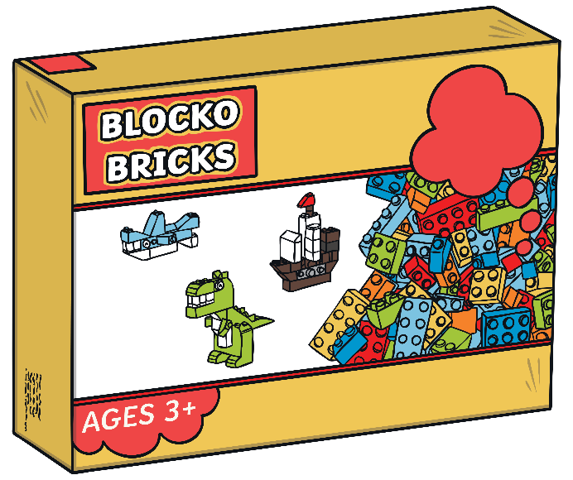
$17.00 per box
Buy 3 boxes and
get one free.

$17.00 per box
$\frac{\text{1}}{\text{5}}$ off every box.

________________________________________________________________________________________________________________________________________________________________________________________________________________________________________________________________________________________________________________________________________________________________________________________________________________________________________________________________________________________________________________________________________________________________________________________________________________________________________________
__________________________________________________________________________________________________________________________________________________________________________________________________________________________________________

PART 2: Collect 1 example of percentages which are used in retail. You can find your resource from magazines, newspapers, catalogues or online. Paste your OWN example in the space provided below. To guide you for some ideas, an example has been provided below for you.
(1 mark)
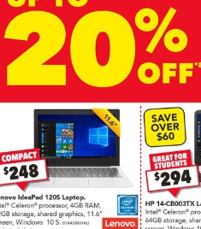
ITEM:

PART 3: Calculate the amount that you would save if you purchased the items shown in your example. NOTE: If your example already shows the savings, show using calculations that the amount is the correct. (2 marks)
______________________________________________________________________________

______________________________________________________________________________

______________________________________________________________________________

Section 3 – GROCERY LIST AND GST

You decide to be a chef for the day and cook yourself lunch. In search for a quick and easy recipe, you choose to cook Margherita Pizza. The list below are the ingredients needed for the success of the dish. Keep in mind the quantity of the ingredients does not matter for the purpose of this activity, leftovers are always good.

PART 1: You are working on a budget of $30 when selecting to purchase items from COLES. By visiting the Coles website (www.coles.com.au), use the search bar to look for the ingredients to purchase. The screen shot below gives a guide.
Ingredients:
- 1 store bought pizza base
- Half cup of shredded fresh mozzarella cheese
- Tomato sauce
- 2 tbsp extra-virgin olive oil
- 2 cloves garlic, minced
- Salt to taste
- Black pepper to taste
- Grated Parmesan cheese for topping

Step 1: On the Coles homepage you should see a bar with a variety of options as shown below in the picture. Click on the Shop Online tab (in brackets below) to access the search meu.

Step 2: Using the Coles search bar, enter the product you wish to search for. Then click on the search button (looks like a magnifying glass to the right of the search bar).
Click here
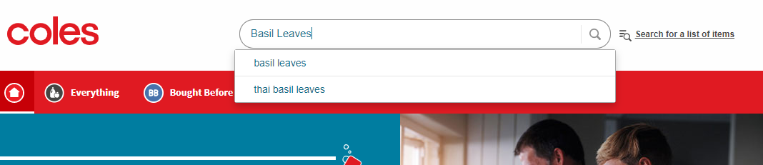

Step 3: After clicking on search, a variety of products are shown matching the item. You can select any one of those keeping in mind of the $30 budget. An example is shown below.
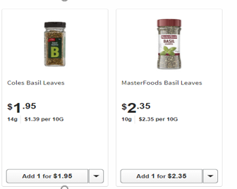

In the space provided below, you are to provide a screen shot of one of the items from the ingredient list you will purchase. (1 mark)

INGREDIENT

PART 2: Complete the table below as part of your grocery list, showing necessary working out. Note: The cost of products will vary depending on which brands you choose. The items have GST including in their pricing. The first one has been done for you. (16 marks)

ITEM | COST (INCL. GST) | GST CHARGED  (2 decimal places)
Pizza Base | $3.00 | $3.00 ÷ 11 = $0.27
Mozzarella Cheese
Tomato sauce
Extra- Virgin Olive Oil
Garlic Cloves
Salt
Black Pepper

Grated Parmesan Cheese

TOTAL

PART 3:

- Referring to part 2, how much did it cost you to purchase all the ingredients? Are you over or under the $30 budget? If so, by how much? Write this as a percentage of the original amount and show all working out. (3 marks)

$Hint : \frac{Amount over or below the budget}{Total Cost}$×100%

________________________________________________________________________________________________________________________________________________________________________________

- Why are some products more expensive than others? What have you realised through this activity when following a budget? Give an example supporting your statement. (3marks)

________________________________________________________________________________________________________________________________________________________________________________________________________________________________________________________________________
________________________________________________________________________________________________________________________________________________________________________________

Section 4 – CONVERSIONS

PART 1: Choose 5 values of your choice and correctly complete the table below (5marks)

Decimal (2 d.p) | Fraction (Simplified) | Percentage (%)

PART 2: Complete the table below (12 marks)

Items | Price for 300g | Price for 2.25kg
Apples
$2.50 per kilo
Carrots
$1.20 per kilo
Bananas
$1.00 per kilo
Spinach
$3.00 per kilo
Oranges
$2.20 per kilo
Broccoli
$2.80 per kilo

ASSESSMENT MARKING CRITERIA
SECTION 1 – DUELLING DISCOUNTS | /18
Part 1 – PICTURES OF PRODUCTS | Marks
- Has provided all three pictures of the items.  - Has provided only two pictures of the items.  - Has provided only one picture of an item.  - Has picture provided.  MA4-1WM Communicates and connects mathematical ideas using appropriate terminology, diagrams, and symbols. | 3  2  1  0

Part 2 – DISCOUNT TABLE
- Demonstrates a thorough understanding of the mathematics involved in solving the problem.  - Uses appropriate mathematical processes in solving the problem without error.  - Demonstrates understanding of the mathematics involved in solving the problem.  - Uses appropriate calculations with either a minor arithmetic or calculation error OR all mathematical calculations have been carried out without error but the final conclusion is incorrect.  - Demonstrates progress towards a solution with some error.  - Demonstrates a developing understanding of what it means to work mathematically with some use of mathematical language, diagrams, notation and symbols.  - Demonstrates a limited understanding of the mathematics involved in solving the problem.  - Demonstrates a limited use of mathematical language or diagrams.  MA4-6NA Solves financial problems involving purchasing goods. | 11–12  8-10  5-7  0-4

Part 3 – REASONING AND JUSTIFICATION
- Clearly justifies with an illustrated example the better circumstance for coupon use  - Demonstrates a clear attempt at providing a reason for better coupon choice with some illustration.  - Does not provide any valid reasoning nor illustration of the coupon of choice  MA4-1WM Communicates and connects mathematical ideas using appropriate terminology, diagrams, and symbols. | 3  1-2  0
SECTION 2 - ADVERTISEMENTS | /7
Part 1 – SAVINGS BY DISCOUNTS | Marks
- Correctly demonstrates capacity to calculate percentage discounts with no errors and arrive to a conclusive decision.  - Demonstrates understanding of percentage discounts with appropriate calculations with minor errors and can develop a conclusion based on their calculations.  - Demonstrates a basic understanding of percentage discounts with some errors but is unable to develop a conclusion.  - Has displayed a limited understanding of percentage discounts with multiple errors and/or non-attempt.  MA4-6NA Solves financial problems involving purchasing goods. | 4  3  2  0 - 1
Part 2 – PERCENTAGES IN ADVERTISEMENTS
- Appropriate picture of an advertisement showing percentage application in retail.  - No picture of an advertisement  MA4-1WM Communicates and connects mathematical ideas using appropriate terminology, diagrams, and symbols. | 1  0
Part 3 – REASONING AND JUSTIFICATION
- Effectively performed calculations with no error  - Has demonstrated capacity to perform percentage calculations with some error.  - Has shown limited to no understanding of percentage calculations with multiple errors.  MA4-5NA Operates with fractions, decimals, and percentages. | 2  1  0

SECTION 3 – GROCERY LIST AND GST | /23
Part 1 – SCREENSHOT OF AN INGREDIENT | Marks
- Has provided a screenshot from the Coles website of an ingredient.  - Has no screenshot.  MA4-1WM Communicates and connects mathematical ideas using appropriate terminology, diagrams, and symbols. | 1  0

Part 2 – GST TABLE
- Demonstrates a thorough understanding of the mathematics involved in calculating GST.  - Uses appropriate mathematical processes and observations in completing the table from minimal to no error | 14-16
- Demonstrates understanding of the mathematics involved with appropriate GST calculations with either a minor arithmetic or calculation error.  - Completes table effectively with minor error to no error | 11-13
- Demonstrates progress towards a solution with some error in GST calculations.  - Table mostly filled out with partial mistakes | 8-10
- Demonstrates some understanding of the mathematics involved in solving the problem.  - Some parts of the table are filled | 4-7
- Demonstrates a limited understanding of the mathematics involved in solving the problem.  - Table has many blanks or is completely left blank.  MA4-5NA Operates with fractions, decimals, and percentages. | 0-3

Part 3 – REASONING AND JUSTIFICATION
- Effectively performs percentage calculations leading to conclusive results with a logical justification based on the scenario.  - Demonstrates understanding of percentage calculations with no error with some links to illustrations.  - Presents some justification based on calculations that indicate minor errors.  - Does not provide any valid percentage calculations nor illustration of supporting examples.  MA4-6NA Solves financial problems involving purchasing goods. | 5-6  3-4  1-2  0
SECTION 4 - CONVERSIONS  Part 1 – Decimal, Fractions, and Percentage Table  - All values are accurate and clearly displayed as decimals, fractions, and percentages.  - Most values are accurate and displayed as decimals, fractions, and percentages.  - Some values are accurate and displayed as decimals, fractions, and percentages.  - Few values are accurate and displayed as decimals, fractions, and percentages.  - Values are inaccurate or not displayed correctly/ No values displayed.  MA4-5NA Operates with fractions, decimals, and percentages. | /17  5  4  3  1-2  0
Part 2 – Price Conversion  - All conversions are accurate, demonstrating precision and attention to detail.  - Most conversions are accurate, with minor errors present.  - Conversions are somewhat accurate, with noticeable errors.  - Few conversions are accurate, with significant errors present.  - Conversions are mostly inaccurate with minimal correct conversions.  MA4-5NA Operates with fractions, decimals, and percentages. | 10-12  7-9  4-6  2-3  0-1

