Year 10 STAR Mathematics
Assessment Task 2025
TOPIC: Financial Mathematics – Household Budget | WEIGHTING: 30%  COMPONENTS:
SUBMISSION REQUIREMENTS:
Due Term 1 Week 10. Wednesday 2nd April, 2025
This task must be submitted via Canvas by 3pm on the due date. Use Google Chrome to search camden.instructure.com and login using your student DET email and password. Go to the STAR Mathematics home page and click on “Assessment” under the Quick Access Links. Select “Submit Here- Mathematics Assessment 1”, upload your file and submit the assignment.

TASK DESCRIPTION:

Congratulations, you have decided to move out of home! Moving out of home is an exciting journey but can also be overwhelming and confusing and that is why it is important to create a budget. Budgeting is an important part of responsible financial management and has many benefits. You will create a budget of your expected income ($690/week) and spending in order to identify the rent you can afford and buy the items you need for your home. You should explore all the financial commitments you would have and solve the financial problem of budgeting by using an appropriate and accurate budgeting template.

The Assessment consists of 3 parts:
- Rent
- Expenses
- Evidence

OUTCOMES TO BE ASSESSED:

MAO-WM-01
develops understanding and fluency in mathematics through exploring and connecting mathematical concepts, choosing and applying mathematical techniques to solve problems, and communicating their thinking and reasoning coherently and clearly
MA5-FIN-C-01
solves financial problems involving simple interest, earning money and spending money
MA5-FIN-C-02
solves financial problems involving compound interest and depreciation

DIRECTIONAL VERBS:
Develop: Construct or convert ideas to improve understanding
Explore: Examine something before making a decision
Solve: Find an answer to, explanation for, or means of effectively dealing with

ASSESSMENT CRITERIA:

Using the Money Smart Website https://www.moneysmart.gov.au/tools-and-resources/calculators-and-apps/budget-planner you are going to create a budget based on the salary of a 1st year apprentice/trainee in the trade/industry you are interested in.

1: Rent
Using the below property websites, select a property that fits into your weekly budget. Your property could be a house, apartment, granny flat etc. You may buddy up and share 1 property with another student from the class.
TIP: Keep in mind that some properties for rent require a bond as well as a number of weeks rent in advance; make sure you can afford these additional payments!
- https://www.realestate.com.au/rent/
- https://www.domain.com.au/
- https://www.gumtree.com.au/
2: Expenses
Using the Money Smart Budget Planner, you will need to account for any expenses that come with moving out of home.
TIP: Research the following expenses and compare different providers to make sure you’re getting the best deals!

Expense | How To Find
- Electricity | Try a Google search such as “average electricity bill (insert suburb your house is in)”
- Gas (if your property requires it) | Try a Google search such as “average gas bill (insert suburb your house is in)”
- Water | Try a Google search such as “average water bill (insert suburb your house is in)”
- Internet | Research and compare home internet plans between companies like Optus, Telstra, Vodafone etc.
- Pay TV/Music (Foxtel/Netflix/Spotify etc.) | Google search the cost of these services if you wish to have them.
- Mobile Phone | Research and compare mobile phone plans between companies like Optus, Telstra, Vodafone etc.
- Furniture | You will need to find individual prices for the below furniture. You can use websites such as Kmart, Ikea, and Gumtree if you wish to buy second hand items.  - Bed frame  - Mattress  - Chest of drawers  - TV and TV unit  - Lounge  - Fridge  - Microwave  - Dinner table and chairs
- Car registration, CTP and Insurance | 1. First go onto a car sales website such as https://www.carsales.com.au/  and select a car that is under $10,000 and where you can visibly see the registration (number plate).  2. Research using the Service NSW website how much it will cost to register your chosen car for the year.  3. Research and compare CTP insurance deals for your selected car. You can use websites like www.comparethemarket.com.au to compare deals.
- Weekly petrol AND/OR Travel (train tickets, parking permits etc.) | If you would be driving to work daily, you will need to work out how many litres the tank in your car is and find the current petrol price per litre. You can do this by going to https://fuelcheck.nsw.gov.au/app  And entering the suburb where your house is and make sure you select the right type of fuel for your car (unleaded 91, unleaded 95, diesel etc.)  (Current petrol price x litres to fill your car’s tank)  E.g.:  The current petrol price in Camden for Unleaded 91 is $1.22/litre  The petrol tank capacity in a Kia Sportage is 62 litres. So, 1.22 x 62 = $75.64/tank
- Groceries (price of a weekly shop) | Go onto either www.woolworths.com.au or https://www.coles.com.au/ and search for items that you will need for a week. Put these items into your shopping cart and tally the total price of your shop. You need to ensure you have the following essentials:  - Lunch for 5x days (e.g.: sandwiches)  - Food for 5x dinners  - Snacks/ extra food  - Hygiene products (body wash/ deodorant  - Cleaning supplies (washing powder/ dishwashing detergent)
- Clothing purchases | Estimate how much you would spend on clothes per year.
- Technology purchases | Estimate how much you would spend on technology per year.
- Sports/Gym memberships | Football/Netball/Gym rego etc.
- Education | TAFE Fees
- Leisure | Estimate how much you would spend on take away food, tickets etc. per month.
3: Research
To prove that your rent and expenses fit into your budget, you will need to provide evidence of the costs. To do this, you are expected to collect any quotes or fees you have found and selected for the above expenses as well as a weekly grocery list with prices. These are to be screenshot using the snipping tool and put into a word document.

Step 1 | Open Snipping tool  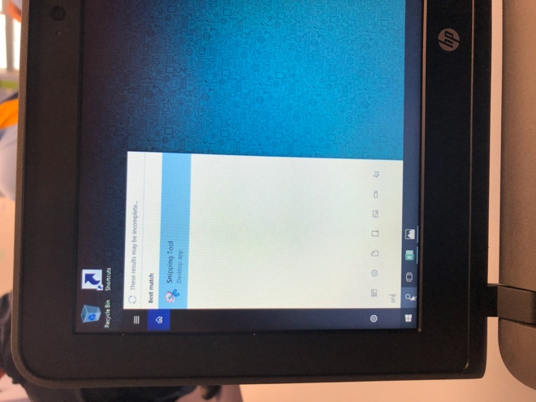 | Step 2 |   Click “New”
Step 3 |   Drag your curser to cover what you want to screen shot | Step 4 |   Check your screen shot to make sure youre happy with it. Ensure you can see the price.
Step 5 |   Click “Save” | Step 6 | 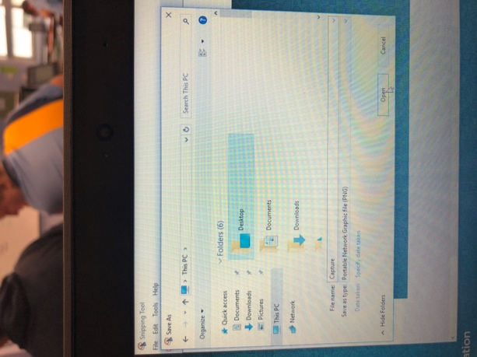  Save to your desktop
Step 7 | Open Microsoft Word and click “Insert”  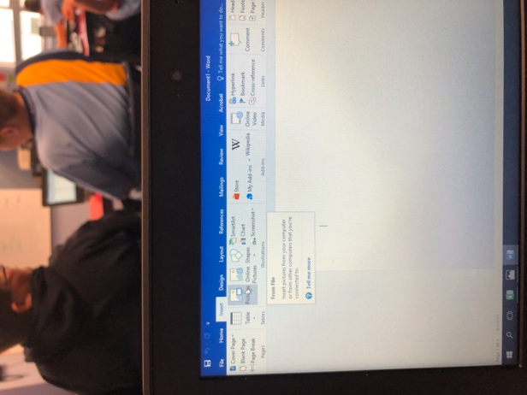  à “Insert Picture” | Step 8 | 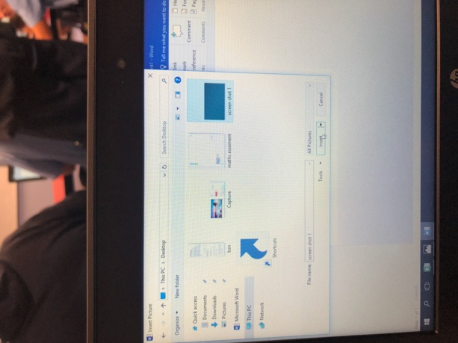  Select your screenshot

ASSESSMENT MARKING CRITERIA
Each section will contribute evenly. | Grade
- Selects an appropriate property that is within the identified budget and includes a copy of the listing.  - Extensively completes the Money Smart Budget Planner and the expenses included are within the identified budget.  - Provides an extensive grocery list for one week that reflects the cost entered into the Budget Planner.  - Provides extensive evidence of all research including quotes and fee estimates | A
- Selects an appropriate property that is within the identified budget and includes a copy of the listing.  - Comprehensively completes the Money Smart Budget Planner and the expenses included are within the identified budget.  - Provides a comprehensive grocery list for one week that reflects the cost entered into the Budget Planner.  Provides comprehensive evidence of all research including quotes and/or fee estimates. | B
- Selects a property that is within the identified budget and includes a copy of the listing.  - Completes the Money Smart Budget Planner and the expenses included are within the identified budget.  - Provides a grocery list for one week that reflects the cost entered into the Budget Planner.  - Provides evidence of research including quotes or fee estimates. | C
- Selects a property that may be within the identified budget and may include a copy of the listing.  - Attempts to complete most of the Money Smart Budget Planner and the expenses included are mostly within the identified budget.  - Attempts to provide a grocery list for one week that may reflect the cost entered into the Budget Planner.  - Provides some evidence of research including quotes or fee estimates. | D
- Does not select a property that is within the identified budget and does not include a copy of the listing.  - Attempts to complete some of the Money Smart Budget Planner and the expenses included may or may not be within the identified budget.  - Does not provide a grocery list for one week that reflects the cost entered into the Budget Planner.  - Does not provide evidence of research | E

FEEDBACK: GRADE: RANK:

