Year 9 HSIE

Assessment Task 2 2023

|  |
| --- |
| **TOPIC**: Sustainable Biomes Research Task |
| **SUBMISSION REQUIREMENTS:**  This assessment task must be submitted via CANVAS by 11:59pm.  **9L1, 9L2, 9L3, 9R4:**  14/08/2023  **9R1, 9R2, 9R3:**  10/08/2023 |
| **OUTCOMES TO BE ASSESSED:**  **GE5-5 Assesses** management strategies for places and environments for their sustainability  **GE5-8** Communicates geographical information to a range of audiences using a variety of strategies |
| **DIRECTIONAL VERBS:**  **Assess:** Make a judgement of value, quality, outcomes, results, or size. |
| **TASK DESCRIPTION:**  Students are research geographical features of ONE Biome from the list below to create an information Brochure which describes the biome, a human induced issue which is causing destruction of the biome and provides an assessment of the management strategies used to protect the Biome.  Biomes to choose from:   * Tundra * Grassland * Desert * Savana * Rainforest   The brochure must communicate the following information:   1. A description of characteristics and features of the chosen biome. Including common flora (plants), fauna (animals), weather (climate and rainfall) and soil type. 2. A climate graph which shows the specific location’s climatic features. 3. Identify ONE human induced issue the chosen biome faces and explain the impact of this issue. 4. An outline of TWO management strategies used in the chosen location to protect the biome from human alteration and/or destruction and **assess** the strategies for their effectiveness. 5. Relevant images and photos that relate to the provided information.   Please note:   * An exemplar has been provided for the brochure. Please refer to this when creating your own.   ***Note****: You must* ***NOT*** *do the Daintree Rainforest.*   * An ALARM scaffold has been included to assist in the planning process. * Students will be provided with 2 lessons in class to further assist with the successful completion of the task. |
| **ASSESSMENT CRITERIA:**  **Students will be assessed on their ability to:**   * Communicate Geographical information in the form of a 2 A4 page information brochure. * Identify and describe features and characteristics of chosen Biome including flora, fauna, weather, and soil type. * Identify and describe one human induced issue the biome faces. * Identify TWO successful management strategies that are used in the chosen Biome and **assess** whether the management strategies are effective in reducing the environmental impact of the specified human induced issues of their chosen Biome. * Use their own words (no plagiarism or use of AI). * Must be 2 A4 Pages of information, in size 12, plain font. |

|  |
| --- |
| **Checklist before submission:**  Make sure that your brochure includes the following:   * Title with your chosen biome, the specific location, your name and class * A description of the characteristics and features of your biome, including:   + Flora and fauna   + Weather (climate and rainfall)   + Soil type * Your climate graph has been correctly labelled with a title, temperature in ℃ and rainfall in mm * There are pictures of your chosen biome and location * You have identified one human induced issue your location faces * You have explained the impact of the issue. * You have outlined TWO management strategies to protect your chosen biome and location * You have assessed (make a judgement on how well the strategy is working to protect the environment and why) the management strategies. |

|  |  |
| --- | --- |
| **ASSESSMENT MARKING CRITERIA** | |
| **GE5-5 Assesses** management strategies for places and environments for their sustainability  **GE5-8** Communicates geographical information to a range of audiences using a variety of strategies | **Grade** |
| The student produced an outstanding brochure that demonstrates extensive knowledge and understanding of the impact of human alterations to biomes and how they can be managed. The student effectively explained the impact of ONE issue caused by human alterations to biomes.  The brochure effectively identified TWO successful management strategies that target the chosen issue and has accurately **assessed** whether the management strategies reduce the environmental impact of the chosen issue. The student has communicated required geographical information in a detailed, logical and cohesive way where all aspects of the task are complete. | A |
| The student produced a detailed brochure that demonstrates thorough knowledge and understanding of the impact of human alterations to biomes and how they can be managed. The student effectively explained the impact of ONE issue caused by human alterations to biomes.  The brochure has identified TWO successful management strategies that target the chosen issue and has effectively **assessed** whether the management strategies reduce the environmental impact of the chosen issue. The student has communicated required geographical information in a detailed way where all aspects of the task are complete. | B |
| The student produced a satisfactory brochure that demonstrates sound knowledge and understanding of the impact of human alterations to biomes and how they can be managed. The student adequately explained the impact of ONE issue caused by human alterations to biomes.  The student has identified TWO successful management strategies that target the chosen issue and has effectively **assessed** whether the management strategies reduce the environmental impact of the chosen issue. The student has communicated required geographical information that is mostly cohesive. | C |
| The student produced a brochure that demonstrates basic knowledge and understanding of the impact of human alterations to biomes and how they can be managed. The student attempted to explain the impact of ONE issue caused by human alterations to biomes. The brochure may have identified TWO management strategies that target the chosen issue but lacked the ability to accurately assess whether the management strategies reduce the environmental impact of the chosen issue. The student has communicated required geographical information in a brief way. | D |
| The student produced a limited brochure that demonstrates an elementary knowledge and understanding of the impact of human alterations to biomes and how they can be managed. Some attempt may be made to explain the impact of an issue caused by human alterations, and the management strategies used but may be lacking detail, accuracy, or depth. The brochure does not communicate the required geographical information, or may not be completed in an ineffective way. | E |

Part A: Brochure Exemplar – Daintree Rainforest

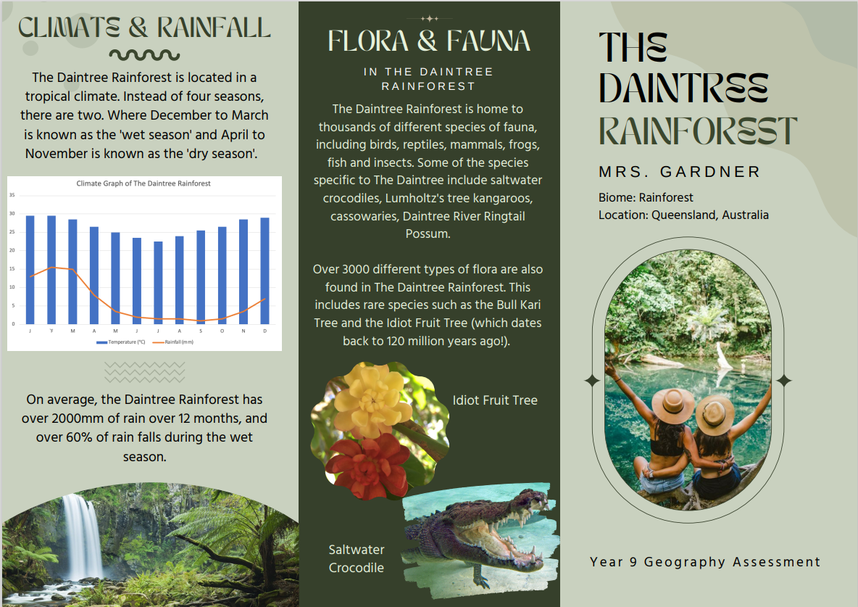

**Year 9 HSIE Assessment Task 2**

**Explain** the impact of ONE of the issues caused by human alterations to biomes.

|  |  |  |
| --- | --- | --- |
| **Identify** | **Describe** | **Explain** |
| **Identify EACH element and then state the definition of EACH part.**  *Identify the issue caused by human alterations to biomes.* | **Describe the characteristics, features, properties, or qualities of EACH of the components.**  *Describe the issue in detail.* | **Consider the purpose or function of EACH feature**  *Explain the impact the issue has on the biome/environment.* |
|  |  |  |

**Assess** a management strategy and its ability to reduce the environmental impact of the chosen issue.

|  |  |  |  |
| --- | --- | --- | --- |
| **Identify** | **Describe** | **Explain** | **Analyse** |
| **Identify EACH element and then state the definition of EACH part.**  *Identify the management strategy for your chosen issue.* | **Describe the characteristics, features, properties, or qualities of EACH of the components.**  *Describe the management strategy in detail.* | **Consider the purpose or function of EACH feature**  *Explain how it positively contributes to reducing the impact of your chosen issue.* | **HOW/WHY each component is attempting to carry out its purpose, role, or function and how each of the components interact with each other to achieve the whole.**  *How much does it impact your chosen issue? What does it achieve?* |
|  |  |  |  |