Year 7 Geography

Landforms & Landscapes Assessment Task, 2023

|  |  |  |  |  |  |  |  |  |  |  |  |  |  |  |
| --- | --- | --- | --- | --- | --- | --- | --- | --- | --- | --- | --- | --- | --- | --- |
| |  |  | | --- | --- | | **TOPIC**: Landscapes and Landforms: Geomorphic Processes Task |  | | **SUBMISSION REQUIREMENTS:**  Wednesday 13th of September, 2023 - Week 9 Term 3.  All tasks are to be submitted to Canvas by 11:59pm. | | | **OUTCOMES TO BE ASSESSED:**  **GE4-1:** Locates and describes the diverse features and characteristics of a range of places and environments.  **GE4-2:** Describes processes and influences that form and transform places and environments. | | | **DIRECTIONAL VERBS:**  **Describe:** List characteristics and features | | | **TASK DESCRIPTION:**  You are to select ONE of the listed coastal areas below and create a 1-page visual display annotated image. In your visual display, you are to locate and **describe** the diverse features and characteristics of the chosen location and describe the geomorphic processes and influences that transform the coastal area.   1. Pick ONE of the following coastal areas:  * Collaroy Beach (NSW) * K'gari (Fraser Island) (QLD) * Stockton Sand dunes (NSW) * Kiama Blowhole (NSW) * Figure 8 Pools (NSW)  1. Include a map which accurately **identifies** the location and provide a **description** of where it is located within Australia which must include; the state or territory, distance (km) and direction from the nearest major town or city, and longitude and latitude reference. 2. To annotate your image, you are to:  * **Describe** the diverse features and characteristics of the coastal area using an annotated image (photo or drawing) eg. Vegetation, Rocks etc. * **Describe** the geomorphic processors that form (create) the coastal area. * **Describe** the influences that transform (change or shape) coastal areas? Eg. Weather events and conditions. | | | **ASSESSMENT CRITERIA:**  Students will be assessed on the ability to:   * Accurately **identify** the location which includes a map and description of the location using Geographical skills and terminology. * **Describe** the features and characters of the coastal area through multiple accurate annotations on the image presented. * **Describe** the geomorphic processors that form (create) the coastal area. * **Describe** the influences that transform (change or shape) coastal areas. E.g Weather events and conditions. | | | **Use the following checklist as a guide before submitting your assessment:**  **I have included the following:**   * A title, including the name of the coastal area * A map that locates the coastal area * A description of the location, including: * Longitude and latitude * State or territory * Distance and direction from the nearest major town or city * An image (photo or drawing) of the location * Annotations around your image that describe the diverse features and characteristics of the coastal area * A description of the processors that form (create) the coastal area? * A description of the geomorphic processors that transform (change) the coastal area? * My sentences are clear and have capital letters ad full stops in the appropriate places. * I have read over my work and made sure I don’t have any mistakes. * I have asked my teacher for feedback and/or submitted a draft 7 days prior to the due date. * I have saved my work with the title “YourName_GeographyAssessment1” * I have utilized the example and ensured that I am following all instructions. | | |

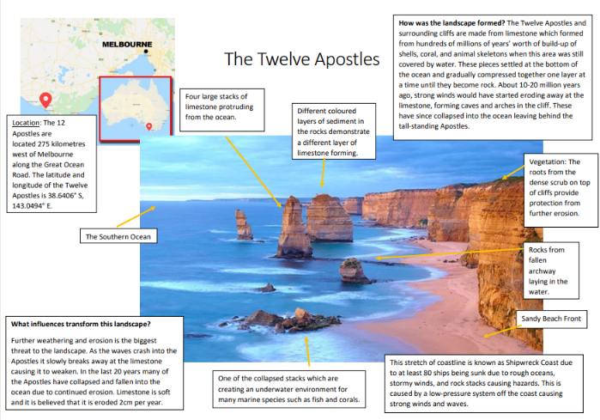**Example:**

|  |  |
| --- | --- |
| **MARKING GUIDELINES**  **GE4-1:** Locates and describes the diverse features and characteristics of a range of places and environments  **GE4-2:** Describes processes and influences that form and transform places and environments | **Grade** |
| The student has created an outstanding visual display that describes to a sophisticated level the diverse features and characteristics of a selected coastal area by annotating an image. An accurate description of the processors and influences that form or transform places and environments has been included. The student has located the coastal area using a map accurately and has consistently included highly relevant geographical terminology throughout. | **A** |
| The student has created a thorough visual display that describes to a high level the diverse features and characteristics of a selected coastal area by annotating an image. A detailed description of the processors and influences that form or transform places and environments has been included. The student has located the coastal area using a map accurately and has consistently included highly relevant geographical terminology throughout. | **B** |
| The student has created a sound visual display that describes the diverse features and characteristics of a selected coastal area by annotating an image. An accurate description of the processors and influences that form or transform places and environments has been included. The student has located the coastal area using a map and has included relevant geographical terminology throughout. | **C** |
| The student has created a basic visual display that attempts to describe the diverse features and characteristics of a selected coastal area by annotating an image. A description of the processors and influences that form or transform places and environments has been included but may include some inaccuracies. The student has attempted to locate the coastal area using a map and may or may not include geographical terminology throughout. | **D** |
| The student has created a limited visual display that makes little attempt to describe the diverse features and characteristics of a selected coastal area and may or may not annotate an image. A limited description of the processors and influences that form or transform places and environments has been included but may include some inaccuracies. The student has not located the coastal area accurately, and lack relevant geographical terminology. | **E** |