Year 8 HSIE
Assessment Task 2, 2023
TOPIC: Place & Liveability | MARKS: /25
SUBMISSION REQUIREMENTS: Submit to Canvas by 11.59pm, Week 6, Term 3, Wednesday, 23rd August 2023. | WEIGHTING: NA
OUTCOMES TO BE ASSESSED:
GE4-3 Explain how interactions and connections between people, places and environments result in change
GE4-6 Explains differences in human wellbeing.
DIRECTIONAL VERBS:
Explain: Relate cause and effect; make the relationships between things evident; provide why and/or how.

TASK DESCRIPTION:

- Select ONE city from the top 10 most liveable and ONE from the top 10 least liveable cities below.
- Create an Infographic which explains the differences in liveability between a highly liveable and a less liveable city.
- Explain the effect the five factors of liveability can have on increasing people’s wellbeing taking, into account people, places and environments. The factors of liveability include: the social, environmental, economic, infrastructure, and cultural factors.
Hint: respond to this question by comparing one of the most liveable cities to one of the least liveable cities

Top 10 Liveable Cities | 10 Least Liveable Cities
- Vienna, Austria  - Copenhagen, Denmark  - Zurich, Switzerland  - Calgary, Canada  - Vancouver, Canada  - Geneva, Switzerland  - Frankfurt, Germany  - Toronto, Canada  - Amsterdam, Netherlands  - Osaka, Japan | - Damascus, Syria  - Lagos, Nigeria  - Tripoli, Libya  - Algiers, Algeria  - Karachi, Pakistan  - Port Moresby, Papua New Guinea  - Dhaka, Bangladesh  - Harare, Zimbabwe  - Douala, Cameroon  - Tehran, Iran

ASSESSMENT CRITERIA:

Choose TWO cities from the list above to compare:
- ONE from Top 10 Liveable Cities and ONE from Top 10 Least Liveable Cities.
- Create an Infographic which explains the differences in liveability using a program like ‘Canva’.
- Each of your images (at least one image for each factor of liveability per city) should allow you to explain the differences between each of the cities
- Explain the effect the five factors of liveability can have on increasing people’s wellbeing – 150-200 words for each factor (no more than 1000 words overall)

This is an example of what an Infographic can look like (this is not the answer to your question)

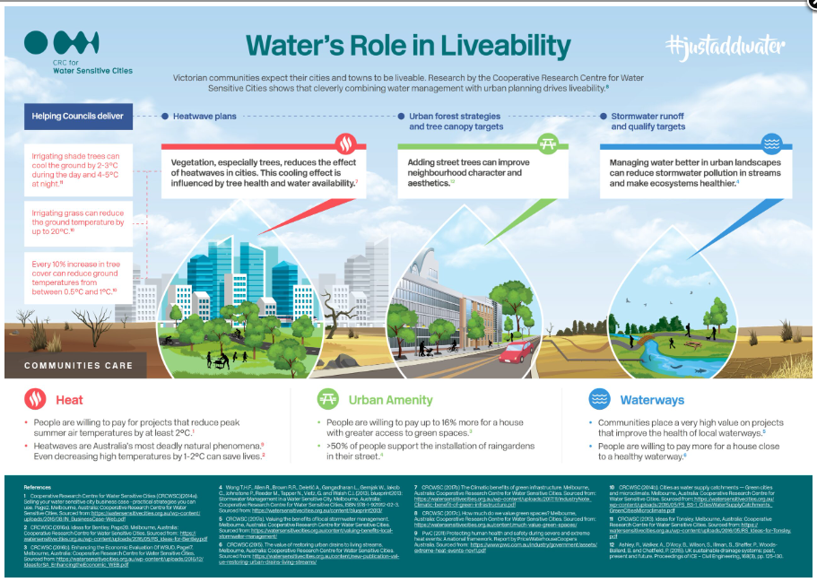

ASSESSMENT MARKING CRITERIA
GE4-3 Explain how interactions and connections between people, places and environments result in change  GE4-6 Explains differences in human wellbeing. | Grade
A comprehensive Infographic has been created which explains the differences in liveability between a highly liveable and a less liveable city using the 10 most and 10 least liveable cities list. Students have provided an outstanding explanation of differences in liveability between two different cities. An Indepth explanation of how the five factors of liveability can increase people’s wellbeing has been provided. | A
A thorough Infographic has been created which explains the differences in liveability between a highly liveable and a less liveable city using the 10 most and 10 least liveable cities list. Students have provided a detailed explanation of differences in liveability between two different cities. A clear explanation of how four to five factors of liveability can increase people’s wellbeing has been provided. | B
A sound Infographic has been created which explains the differences in liveability between a highly liveable and a less liveable city using the 10 most and 10 least liveable cities list. Students have provided an explanation of differences in liveability between two different cities. A satisfactory explanation of how three-four factors of liveability can increase people’s wellbeing has been provided. | C
A basic Infographic has been created which describes the differences in liveability between a highly liveable and a less liveable city using the 10 most and 10 least liveable cities list. Students may have provided an explanation of differences in liveability between two different cities. An attempt has been made to explain how some factors of liveability can increase people’s wellbeing has been provided. | D
Student has attempted to provide information on the factors of liveability, this may or may not be presented as an Infographic or refer to two cities. Student has identified how factor/s of liveability relate to people’s wellbeing. | E

