Year 10 Commerce
Task 2
The Economic and Business Environment Assessment Task 2023

TOPIC: Current Economic Issues Presentation (Infographic) | MARKS: /20
SUBMISSION REQUIREMENTS:  Thursday 25th May Week 5, to be submitted via CANVAS by 11:59pm  If you are unable to submit the task on the due date, you are required to submit an illness/Misadventure form (including relevant evidence) which is in the Year 10 Assessment Booklet and on the school website. | WEIGHTING:
OUTCOMES TO BE ASSESSED:
COMM5-5 - Evaluates options for solving problems and issues.
DIRECTIONAL VERBS:
Evaluates - Make a judgment based on criteria; determine the value of
TASK DESCRIPTION:
You are to create an infographic that investigates a major economic event or development that has impacted Australian consumers and/or businesses in recent years. Choose ONE major economic event from this list:
- COVID-19
- Current interest rate increases
- Australia’s sourcing trade relations with China

Your infographic must explain what caused the event, and then evaluate what impact it has had on Australian businesses/consumers. You need to also evaluate the responses set by stakeholders (such as government/agencies/businesses) to overcome the challenges of your chosen economic event. You must apply relevant commercial and legal concepts and terminology relevant to the course and include a well-formatted bibliography.
ASSESSMENT CRITERIA:
In your infographic, you need to cover the following aspects:
- Provide a brief outline of your chosen major economic event or development. (approx. 50-80 words)
- Explain the cause/s of your chosen major economic event or development? (approx. 80-100 words)
- Evaluate the impact of this event on Australian businesses and consumers (consider the following: which groups have been impacted by this economic event or development? In what ways, and to what extent, have these groups been impacted? (approx. 100-150 words)
- Evaluate the responses that were put in place to overcome the challenges that this major economic event or development caused? (Consider the following: Who enabled/created these responses? How effective were they in dealing with the challenges of this major economic event or development? (approx. 100-150 words)
Ensure you cover the responses from a range of stakeholders or groups (e.g. Governments, consumers, agencies and businesses)

Remember: An infographic is a visual representation of information, data and knowledge presented in a simple format to allow people to access the information quickly and easily. You should use a range of images, graphs, charts, maps, and written information to help you express your ideas. Ensure that access is granted to your infographic, this can be through the website or through a PDF upload onto Canvas – Make sure you check this before 11.59 pm on the due date.

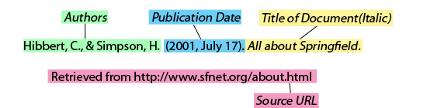
You need to include a bibliography of sources used (this can be included on a separate document to your infographic) See the example format below:

You can use Canva.com (or an infographic tool of your choosing) to design your task. Below are some examples of effective infographics:
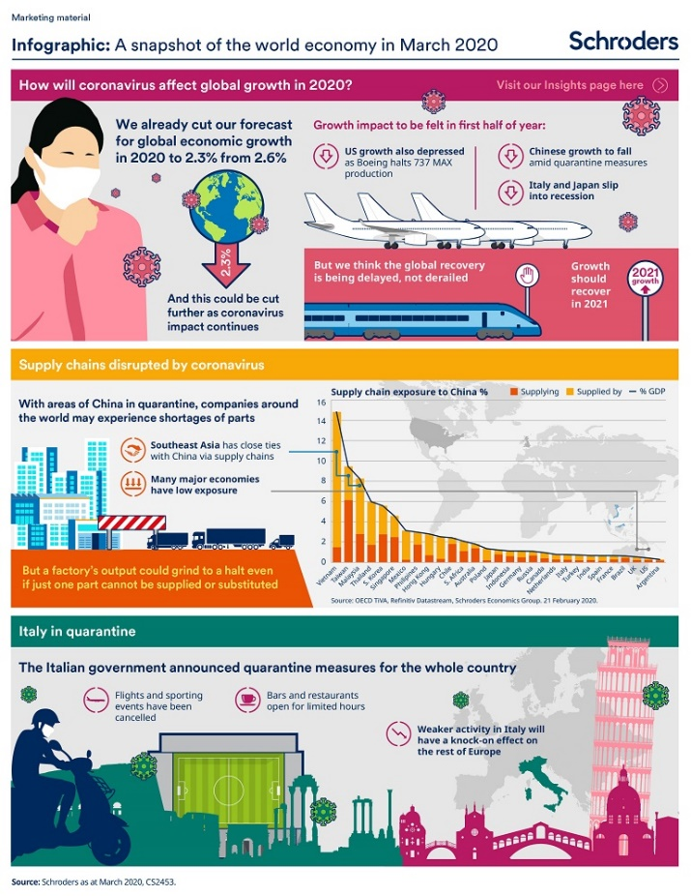
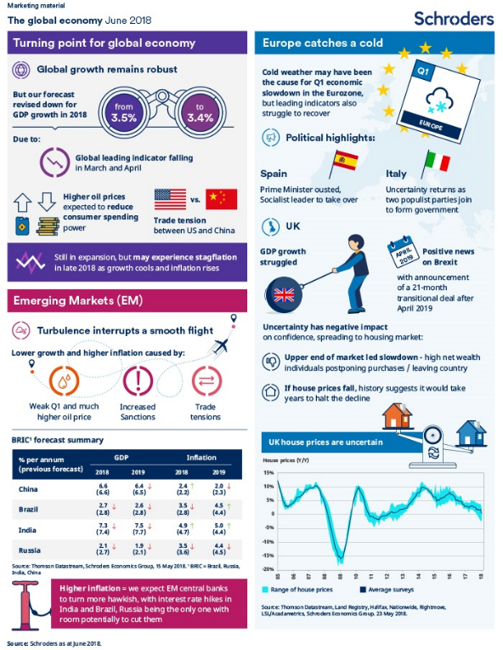

- Use the planning document provided on the following page to help you organise your information.
- As per the draft policy, please ensure drafts are submitted via email to your teacher 7 days prior to the due date. Include an appropriate question which your teacher can supply feedback on.

Planning Document:
Name of economic event: ____________________________________

(Who, What, Where, When)  Provide a brief outline of your chosen major economic event or development. | (How/Why)  Explain the cause/s of your chosen major economic event or development.
(Value judgment - What is the impact / how much of an impact)
Evaluate the impact of this event on Australian businesses and consumers:
- which groups have been impacted by this economic event or development?
- In what ways what they been impacted?
- To what extent have they been impacted?
Here you should be including evidence of the impact in the form of data. You should include statistics, graphs or charts to back up what you are saying.
(Value judgment – how successful)
Evaluate the responses that were put in place to overcome the challenges that this major economic event or development caused.
- What were the responses?
- Who enabled/created these responses?
- How effective were they in dealing with the challenges of this major economic event or development?
Ensure you cover the responses from a range of stakeholders or groups (e.g. Governments, consumers, agencies, and businesses. Use data to back up your judgment about how effective it is.
Keep a record of all websites that you will need for your bibliography below:
Who will need to include: Author, Date, Title, URL

ASSESSMENT MARKING CRITERIA
COMM5-5 - Evaluates options for solving problems and issues | Grade
Students have produced a comprehensive, cohesive and sophisticated infographic which demonstrates an excellent understanding of their chosen economic event. The infographic offers an extensive demonstration of the impact of the economic event and a highly detailed evaluation of the responses from a range of applicable stakeholders. Relevant commercial concepts and terminology are used consistently throughout the infographic. A range of sources have been cited in an accurate bibliography. | A
Students have produced a detailed infographic which demonstrates a thorough level of understanding of their chosen economic event. The infographic offers a thorough demonstration of the impact of the economic event and a clear evaluation of the responses from a range of applicable stakeholders. Relevant commercial concepts and terminology are used consistently throughout the infographic. A range of sources have been cited in a bibliography. | B
Students have produced a sound infographic which demonstrates a sound level of understanding of their chosen economic event. The infographic offers a sound demonstration of the impact of the economic event and an evaluation of the responses from a range of applicable stakeholders. Relevant commercial concepts and terminology are used throughout the infographic. An attempt to cite sources in a bibliography has been made. | C
Students have produced an infographic which demonstrates a basic level of understanding of their chosen economic event. The infographic offers a basic demonstration of the impact of the economic event and may include some evaluation of the responses from a range of applicable stakeholders. Relevant commercial concepts and terminology may be used within the infographic. An attempt to cite sources in a bibliography may or may not have been made. | D
Students have produced an infographic which may demonstrate a limited level of understanding of their chosen economic event. The infographic may offer some relevant information about the impact of this economic event and/or the responses from a range of applicable stakeholders. No bibliography has been included. | E

