Blues Performance

7 Music

Assessment Task 3 2023

|  |  |
| --- | --- |
| **TOPIC**: Blues | **Total Marks: /15** |
| **SUBMISSION REQUIREMENTS:**  Term 3 Week 8. Students will be given a schedule for performance that will occur in class time during the assessment week. | **Weighting:** N/A |
| **OUTCOMES TO BE ASSESSED:**  4.2. **Performs** music using different forms of notation and different types of technology across a broad range of musical styles.  4.3. **Performs** music **demonstrating** solo and/or ensemble awareness. | |
| **DIRECTIONAL VERBS:**  **Perform** –present to an audience  **Demonstrate** – to prove or make clear | |
| **TASK DESCRIPTION:**  This assessment task has two sections:  **Part A:** ***perform*** the 12 bar blues chords and a walking bass line in an ensemble.  *Optional Performance*  *Students have the option to a include the following: A swing pattern on the drums and/or a melodic line (instrumental or vocal) with the rest of the ensemble.*  **Part B:** ***perform*** an improvisation ***demonstrating*** an understanding of the blues scale. This will be played over a backing track. Students should improvise a melody, using note from the C Blues Scale as rehearsed in class. | |
| **Assessment Criteria**: Students will be assessed on their ability to:   * **Perform** within an ensemble and always maintain a strong and steady beat * **Perform** chords and the walking bass line at the same time * **Demonstrate** advanced technical skills * **Demonstrate** knowledge of the blues scale and ability to improvise melodic ideas | |

**To complete the assessment, follow the steps below:**

**Step 1: Learn the chords for the blues in your right hand**

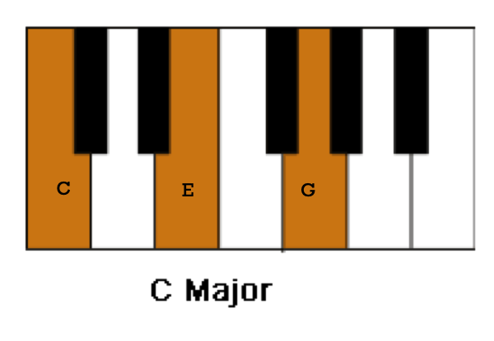

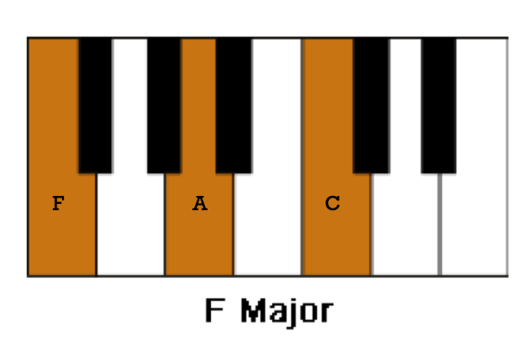

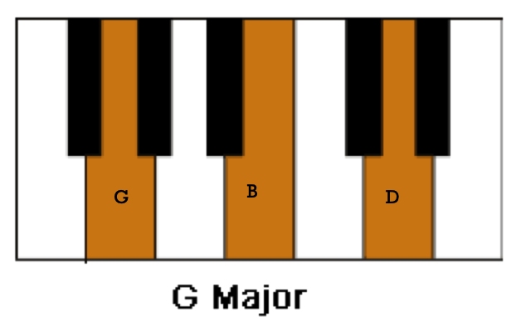

**Step 2: Learn the bass line for the 12 bar blues. It has been provided as notes or letters (read left to right.)**

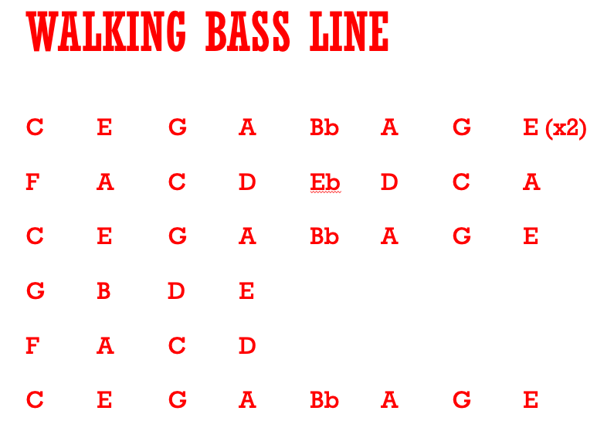

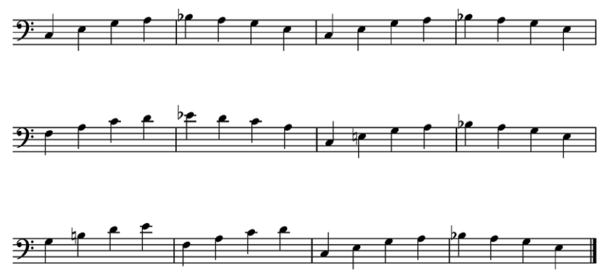

**Step 3: Learn to play the chords and the bass line together in your ensemble.**

**Step 4: Practice improvising using the blues scale below (the highlighted notes).**

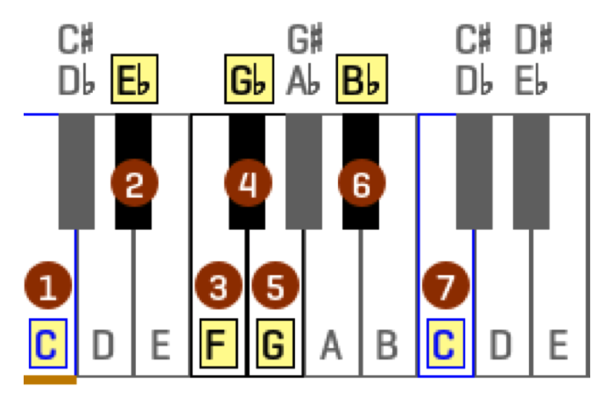

|  |  |  |
| --- | --- | --- |
| **Performance Assessment Marking Criteria: Part A**  **Outcome 4.3** | **Grade and Mark** | |
| * Performance within the ensemble always maintained a strong and steady beat * The chords and the walking bass line are played at the same time * Advanced technical skills are demonstrated | A | **9 - 10** |
| * Performance within the ensemble maintained a strong and steady beat. * The chords and the walking bass line are played at the same time * Proficient technical skills are demonstrated | B | **7 - 8** |
| * Performance within the ensemble maintained a beat with a few mistakes whilst playing: * Chords and the walking bass line are played separately or very slowly together * Sound technical skills are demonstrated | C | **5 - 6** |
| * Performance within the ensemble maintained a beat, however: * various mistakes were evident in either the chords or bass line * The walking bass line and chords are played separately * Basic technical skills were demonstrated | D | **3 - 4** |
| * Performance within the ensemble required significant assistance to play: * the chords * the bass line * Limited technical skills were demonstrated | E | **1 – 2** |
| Comments | | **Out of 10** |

|  |  |  |
| --- | --- | --- |
| **Performance Assessment Marking Criteria: Part B**  **Outcome 4.2** | **Grade and Mark** | |
| * Student is able to perform an improvisation using excellent timing along with a backing track. * Improvisation uses the notes from the blues scale * Improvisation uses creative melodic lines | A | **5** |
| * Student is able to perform an improvisation using appropriate timing along with a backing track * Improvisation uses most of the notes from the blues scale * Improvisation uses melodic lines | B | **4** |
| * Student is able to perform an improvisation in time along with a backing track * Improvisation uses a few of the notes from the blues scale * Improvisation uses melodic lines but there may be inconsistencies | C | **3** |
| * Student has some difficulty performing an improvisation using a backing track * Improvisation may or may not include the notes in the blues scale * Improvisation uses basic melodic lines with inconsistencies | D | **2** |
| * Student is able to perform an improvisation using appropriate timing along with a backing track * Improvisation is on one note * Improvisation uses limited or no melodic lines | E | **1** |
| Comments | | **Out of 5** |