**CAMDEN HIGH SCHOOL**



**2024   
Student Handbook**

**Principal’s Message**

Quality teaching and learning is our core business at Camden High School and each student is supported to achieve their personal best in all aspects of school life. Classes and programs are structured to meet the needs of students and cater for a wide range of learners, as the students are central to all decision making.

A team of experienced and dedicated teachers and school administrative staff support students to develop their skills as learners and encourage participation in school programs that will enhance their academic and social success.

Students are encouraged to be involved in the many academic, sporting, artistic, leadership, agricultural, public speaking and community service programs on offer at school and their achievements are acknowledged at assemblies and presentations throughout the year.

Camden High School is part of the foundation of the Camden community, with its historical past forging strong partnerships with students of today. Students, teachers and parents work together, as they have done in this community for over half a century, to create a positive learning environment that prepares students to be contributing members within our society.

Camden High School is an outstanding example of the power of public education, and it is my desire that all students of this school look back on their time here as some of the best years of their lives. I look forward to meeting each of you over the coming months.

Karen Woods  
Principal

**School Information**

**Address:** 300 Cawdor Road Telephone: (02) 4655 9191  
 CAMDEN Email: [**camden-h.school@det.nsw.edu.au**](mailto:camden-h.school@det.nsw.edu.au)

Website: [**camden-h.schools.nsw.gov.au**](mailto:camden-h.school@det.nsw.edu.au)

**Staff Directory**

**Principal:**  - Mrs K Woods  
**Deputy Principal:** - Mr T French (Years 7 & 10)  
**Deputy Principal:** - Mrs J Tyson (Years 9 & 12)  
**Deputy Principal: -** Ms D Kedward (Years 8 & 11)  
**Deputy Principal:** - Mrs E Griffiths (Inclusion & Support)   
 **Head Teachers:** English - Ms S Bendeich (Rel.)  
 Mathematics - Ms L Macey  
 Science - Ms A Bromley (Tue/Wed/Thur)  
 - Mr S McKenzie (Rel.) (Mon/Fri)  
 HSIE - Ms R Fascioli  
 PD/Health/PE - Mr J Garland  
 TAS - Ms R Duryea  
 Creative & Performing Arts - Mr E Moore  
 Support Unit - Ms M McIlwain  
 Administration - Mr C McKimm  
 Wellbeing - Mr J Berrell  
 Secondary Studies - Mrs J Bui (Rel.)  
 Teaching & Learning - Mr M Johnston (Rel.)

**Year Advisers:**

Year 7 Ms T Dargan Mr J O’Brien  
 Year 8 Ms C Guy TBA  
 Year 9 Mr S Hannah TBA  
 Year 10 Ms V Savignano Ms M Russell  
 Year 11 Mr K Usher TBA  
 Year 12 Ms A Cook Ms M Heath

**Careers Adviser:** Mrs K Abelitis  
**School Counsellors:**  Mrs L Heiler / Ms J Waites  
**School Administration Manager:** Ms J Ryan  
**Business Manager:** Ms L Dillon

**2024 School Calendar**

|  |  |  |  |
| --- | --- | --- | --- |
| **Term 1** | **Term 2** | **Term 3** | **Term 4** |
| 30 January to 12th April | 29 April to 5th July | 22 July to 27th September | 14 October to 20th December |

* Years 7, 11 & 12 first day Thursday 1st February, 2024
* Years 8, 9 & 10 first day Friday 2nd February, 2024
* School Development Days (students do not attend) are scheduled for:  
   30th and 31st January, 29th April, 22nd July and 19th and 20th December

**School Structure and Timetable**

|  |  |  |  |
| --- | --- | --- | --- |
| **Mon, Tues, Wed & Fri** | | **Thurs – Sports Day (for juniors)** | |
| 8.40 - 9.00 | ROLL CALL | 8.40 - 8.50  8.50 – 9.00 | ROLL CALL  ASSEMBLY |
| 9.00 -10.00 | PERIOD 1 | 9.00 -10.00 | PERIOD 1 Years 9, 10, 11 & 12  Years 7 & 8 Sport |
| 10.00 -11.00 | PERIOD 2 | 10.00 -11.00 | PERIOD 2 Years 9, 10, 11 & 12  Years 7 & 8 Sport |
| 11.00 – 11.30 | RECESS | 11.00 – 11.30 | RECESS |
| 11.30 – 12.30 | PERIOD 3 | 11.30 – 12.30 | PERIOD 3 for Years 7, 8, 11 & 12  Years 9 & 10 Sport |
| 12.30 – 1.30 | PERIOD 4 | 12.30 – 1.30 | PERIOD 4 for Years 7,8,11 & 12  Years 9 & 10 Sport |
| 1.30 – 2.00 | LUNCH | 1.30 – 2.00 | LUNCH |
| 2.00 – 3.00 | PERIOD 5 | 2.00 – 3.00 | Early Finish |

**Early Finish Thursday**

During Lunch a shuttle bus service will be provided to central locations across our local feeder areas. This shuttle bus service will enable students to arrive home at an earlier time but it is not the normal bus routes. (see Page 19 for Early Bus timetable). The regular school bus service will still operate from 3pm onwards. If students opt to stay at school on this early finish day, minimal supervision and suitable facilities will be provided to enable students to engage in homework, study or the completion of assessment tasks.

**Special Religious Education**

The opportunity to participate in SRE lessons is provided to those Year 7 and 8 students who have indicated on their enrolment forms that they want to pursue religious education opportunities at school. Scripture lessons have a ‘life-skills’ theme rather than a doctrinal approach.

**School Map**

**Individual Roles of Personnel**

* **Class Teachers** will help and advise students. Do not be afraid to ask questions and seek help when needed.
* **Year Advisers** look after the welfare of a year group. They are interested in students as people and will be available to make sure that students understand what is expected of them, to allay any doubts or fears they may have and to provide guidance and support in particular circumstances. The Year Adviser is a liaison person between the parent and the school, and their role is to advise in areas of concern. However, for matters relating to a specific subject, the Head Teacher of that subject should be contacted. The Year Adviser is available for interview, by appointment. The key role of the Year Adviser is Pastoral Care. This will occur with the whole group, in small groups as well as individually.

* The **Head Teacher Wellbeing** coordinates whole school student welfare programs. They have meetings with Year Advisers, monitor student progress and liaise with the learning support team.
* **Deputy Principals** have the role of the day-to-day organisation and running of the school. They are also responsible for the implementation and monitoring of all curriculums in terms of teaching and learning. This includes faculty programs and assessment policies. Students who are experiencing learning problems are eventually referred to the Deputy Principal. In most cases students will visit the Deputy Principal only if directed by another teacher or if there is a need to inform the Deputy of a problem. The Deputy Principals approve requests to leave the school **(Early Leave)** during school hours.
* The **Principal** is always interested in what goes on in the school. Whilst they are confident to delegate routine matters to staff, this does not mean that they are detached from the day-to-day school life experiences of students, staff, parents and community in the school. The Principal’s job is to provide the educational and managerial leadership of the school.
* **School Counsellors** have special training in educational psychology and counselling as well as teaching experience and are available to help individual students with personal and educational problems. Students may self-refer or may be referred by teachers or parents. The main role of school counsellors is to support the wellbeing needs of students, to offer crisis intervention, to facilitate mental health assessments and to advocate between families and external service providers. A School Counsellor is available at Camden High School on most days of the week.
* **Wellbeing Support Staff** – we have two specialist staff (Student Support Officer, Chaplain) who have been tasked with the responsibility of supporting students who are experiencing difficulties. These staff can be found in our Library.
* **Learning and Support Staff** – we have specialist staff who work with students with identified needs. These staff can be found in the library.
* **Interviews**

Parents and guardians requesting an interview with a member of staff should make an appointment by phoning the school in advance as it is not always possible to make time available for people who arrive unannounced as most teachers have a rigid teaching timetable that must be adhered to.

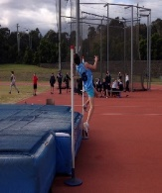

**CCTV**

Camden High School has CCTV throughout the premises. CCTV is used for monitoring:

* after-hours security
* during the course of the working day for added security
* sick bay
* playground and learning activities.

**Student Leadership Council**

An active student leadership team exists in the school which provides opportunities for students to develop leadership skills and be involved in the total life of the school. Representatives are elected from Year 7 to 12. In addition, the School Captains will lead the student leadership council and will meet daily as a Roll group.

**Sport Leadership**

**Camden High School Mobile and Digital Device Management Systems**

The locked device pouch will keep your phone locked and secure during the school day.

You will be provided with a pouch at the commencement of your schooling. When you enter the school grounds, the phones must be placed into your pouch and closed. A pin mechanism then locks the pouch, and the only way it can be opened is by passing it over an unlocking station. It means you can’t access your phone or digital device during school hours.

Once school is finished, you will wave your pouch over the unlocking station when exiting, you will then have full use of your phone again.

There are several unlocking stations in various locations around the school. Each faculty, along with the front office, will have portable unlocking stations.

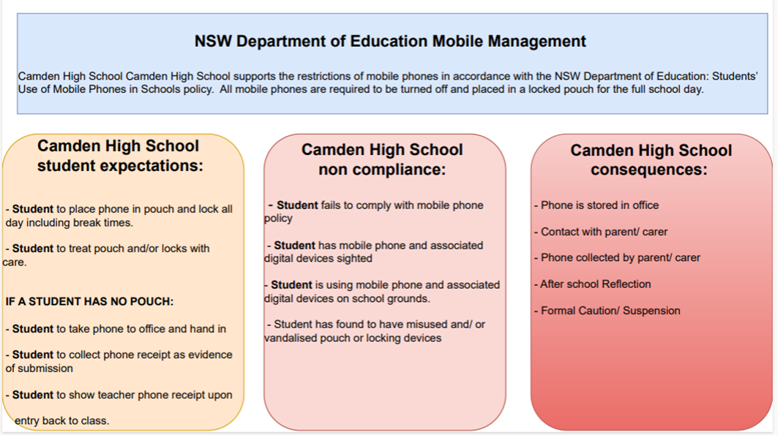

**Student Wellbeing**

In striving for excellence, emphasis is placed on the importance of self-discipline, the acceptance of responsibility by individual students for their own behaviour and learning, and on mutual respect for others and their possessions.

A partnership between students, parents and staff ensures a shared responsibility for developing positive communication processes and effective learning and teaching practices, to meet the individual learning and wellbeing needs of every student at the school.

Expectations of our partnership include:

* a sustained application to learning,
* courtesy and respect for other students, teachers & community members,
* compliance with all school rules and the School Discipline Policy, regard for personal possessions and the school environment,
* adherence to the standards of dress determined by the school community,
* acceptance by parents and caregivers of a shared responsibility for student behaviour and acknowledgement that school authorities have the right to enforce rules and requirements.

These expectations will occur in an environment that endeavours to be free of violence, discrimination, harassment or bullying, weapons, illegal drugs, alcohol and tobacco. The Camden High School Anti-Bullying Plan can be found on our school website which explains our processes in much more detail.



<https://stymie.com.au>

Stymie is a website empowering students to stand up for their rights and is an anonymous online platform that allows parents and students to report bullying incidents to the school. It is available 24 hours a day, 7 days a week. Once a report is made online, a notification is sent to the principal, the deputy principals and the head teacher wellbeing, so they can follow it up.

*“Engaging bystanders is the key to disrupting the cycle of bullying, cyber bullying and harm; making your school an even safer place to learn”.*

For all school and Department of Education policies please visit our website: [**camden-h.schools.nsw.edu.au**](mailto:camden-h.school@det.nsw.edu.au)

**Assessment Policy**

Assessment booklets are available for all students in years 7-12. Each student is issued with a booklet and if lost, it can be found on our website. Go to [www.camden-h.school@det.nsw.edu.au](http://www.camden-h.school@det.nsw.edu.au) and click on the blue ribbon – Assessment Task and Current Notes, select the year and you will find the assessment booklet for that year at the top of the page.

**Movement in and about the school**

Students are required to move quickly and quietly to and from their classrooms keeping to the left of the corridors. No student is permitted inside the buildings before school, at recess or at lunchtime, unless:-

1. It is wet weather and students have been directed by staff
2. He/she is using the Library
3. He/she is required to be there by a member of staff
4. Conducting business at the Administration Office

**Attendance Procedures**

Student attendance at school has a dramatic impact on academic achievement and social and emotional wellbeing for individual students. Quality student attendance results are achieved when schools and families work in partnership to support every student.

Every absence from school, whether short or long term, must be explained in writing the day the student returns to school*.* Notes and emails are filed and must be available for perusal by Department of Education personnel, including the Home School Liaison Officer. Notes are to be handed to your child’s roll call teacher. Absence from school is notified via email on the day of the absence.

**Late Arrival:** If a student is late, he/she should report to the Front Office and should provide a note explaining the cause of the lateness. If a bus is late a note is not required.

**Absence Notes:** If a student is absent from school, it is a requirement that a note or email fully explaining the absence is submitted. Please clearly indicate the student’s name, date of absence and reason for absence. If a holiday or another type of leave is known in advance, please notify the school in the same fashion.

**Early Leave:** Occasionally, it is necessary for a student to request to leave school early. Requests for early leave are to be in writing and require, the student’s full name, date, departure time, full explanation for the request and caregiver’s signature. These requests are to be approved and signed by a Deputy Principal before school and presented to the front office at the time of departure.

**Parental Notes:** All letters to the school should be:

1. WRITTEN and SIGNED by Parent/Carer
2. Headed with:
   1. Name, Year, and class of student (printed)
   2. Address and telephone number
   3. Date
3. Addressed to the person concerned (i.e. Year Adviser, Principal, Deputy Principal etc)
4. Written on a full sheet of paper.
5. If any person is acting as a temporary guardian (e.g. holidays) please notify school regarding dates of this arrangement.
6. If parent’s surname differs from student, please **PRINT FULL NAME OF STUDENT** at top of page.

Where absences remain unexplained, they will be recorded as unjustified on the student’s report. Please call the school if you know your child will be absent for two days or more.

**Extended Vacation Leave Forms**

Parents are encouraged to take holidays with their child during school vacation periods. Travel outside of school vacation periods are counted as an absence.

If you are taking leave outside of school holidays, you will need to complete the Department’s *Application for Extended Leave – Travel. Forms* can be collected from the office. Relevant travel documentation such as an e-ticket or itinerary must be attached to the application.

Please allow a few days for the application to be processed and approved. On approval the Principal will issue a Certificate of Extended Leave – Travel. A copy will be retained on the student’s file.

**School Uniform**

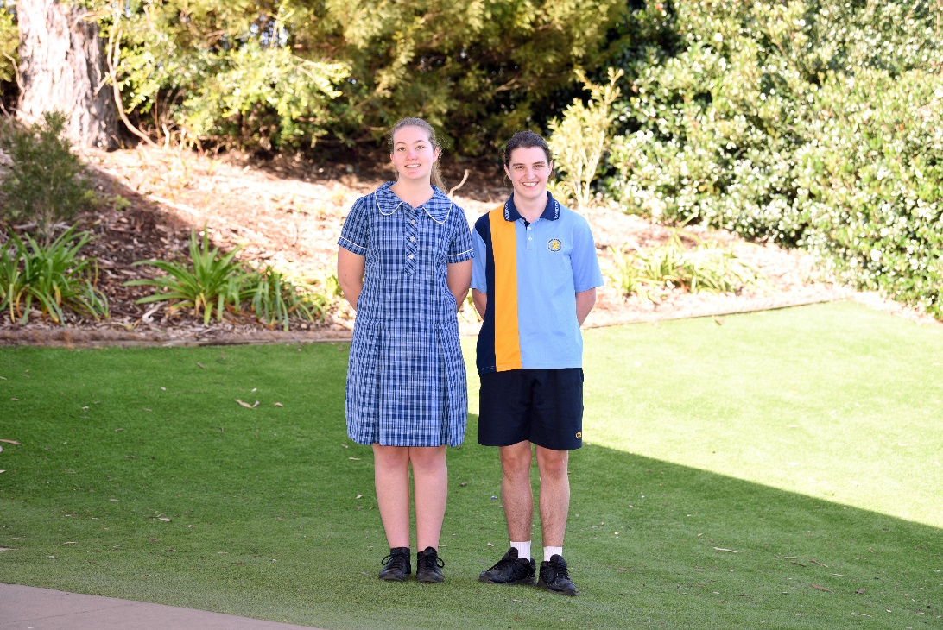 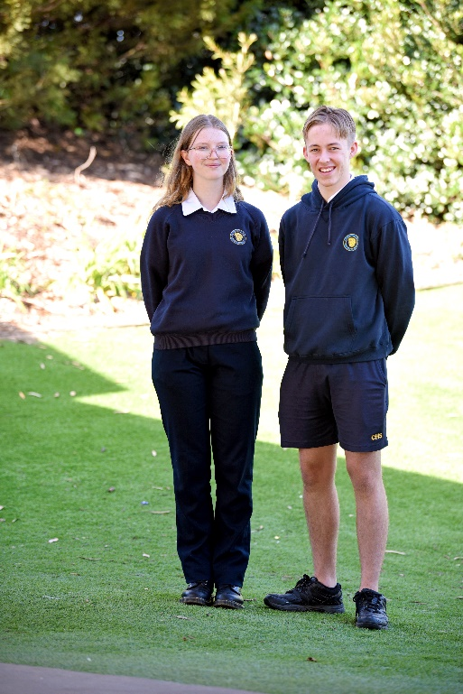 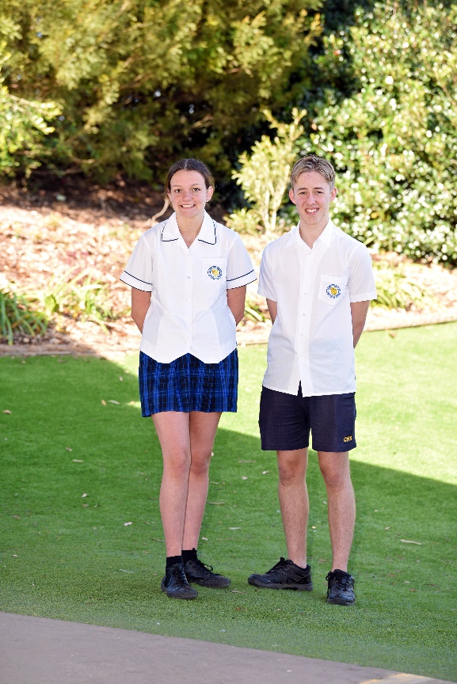

Camden High School requires that each student wear the approved school uniform. School uniforms are available from Yeronga School Uniforms, Camden. Every student must wear full school uniform every day. Sports shoes can be worn by students in Year 7-10 to school, all day, on Thursdays for Sports Day but shoes will need to be brought to school and changed into on other days when PE practical lessons are timetabled.

|  |
| --- |
| **JUNIOR UNIFORM** |
| School Dress  Navy blue tailored pants or track suit pants or mid-thigh shorts  CHS polo shirt  CHS Navy blue sports shorts  **NO DENIM** |
| CHS sloppy joe, hoodie or jacket |
| Black covered leather shoes with black laces  **No canvas or other cut-down shoes, e.g. Ballet flats or Mary Janes Shoes should be plain black with no other colours** |
| Plain white or black socks Navy, black or flesh coloured stockings – no patterns |
| **SENIOR UNIFORM** |
| Navy blue tartan skirt Navy blue tailored pants or track suit pants or med-thigh shorts **NO DENIM** |
| CHS white shirt CHS navy woollen jumper, sloppy joe, hoodie or jacket |
| Black covered leather shoes with black laces. **No canvas or other cut-down shoes, e.g. Ballet flats or Mary Janes.  Shoes should be plain black with no other colours.** |
| Plain white or black socks Navy, black or flesh coloured stockings – **no patterns** |
| **SPORT UNIFORM** |
| Fully enclosed sport shoes with adequate ankle support in any colour.  These do not need to be fully leather |
| Plain white or black socks |

**Canteen Menu**

**\*Please Note:** tights are **not** part of the school uniform and are banned from being worn to school.

**Canteen Menu**

Students wishing to use the canteen can place their order before school each morning, the canteen is located in J Block near the hall and accepts EFTPOS. Students will then pick up their order during Recess or Lunch. Students can also purchase food during Recess or Lunch. Mobile phones are not able to be used for canteen purchases.

**Care of Property and School Cleanliness**

Students are expected to take care of their own property and that of the school. The finder of lost property should take it to the Administration Office.

The student’s name should appear on each item of uniform, and on notebooks. The student’s school bag should be clearly marked for easy identification as well.

Students are advised **NOT** to bring large amounts of money, mobile telephones, iPods or other valuables to school. If for some reason large amounts of money must be brought to school, hand it in at the Administration Office for safe keeping during that day. Do not leave wallets in unattended school bags. Wallets containing bus/train passes/money should be kept with you. During PE and school sporting activities, students are advised to leave all monies and valuables in the custody of the PE teachers or teacher in charge of the sporting group.

Bins are provided in classrooms and in the playground and should be used for the disposal of rubbish. Defacement of school property will be regarded seriously, and parents of offenders will be required to reimburse the school for any damage caused. **Chewing gum is banned at Camden High School.**

**Reports**

Each student’s achievement and progress in class is assessed by their classroom teacher. Teachers use a variety of ways to assess students both formally and informally, including observation of classwork, assessment tasks, information reports, practical tasks, and exams. They make assessments about each student’s progress throughout the year.

Teachers will also make judgements twice a year of each students’ achievement compared with the expectations described in the syllabuses for each KLA subject. Their judgements are made on a five-point achievement scale, using A-E or the word descriptors; Outstanding, High, Sound, Basic and Limited.

Reports are issued at the end of Terms 2 & 4 via email. Year 12 final reports are also printed.

**Emergency Procedures**

An emergency procedure exists for evacuating the school premises if required. It is signalled by 10 tones followed by an evacuation message OR repeated megaphone siren. The students are to vacate the building in an orderly fashion, using exits according to notices posted within every classroom in the school and following all teacher instructions. Students should familiarise themselves with the exits relevant to the classrooms they are in. The designated ‘Safe Area’ is the top basketball court. Emergency procedures are practised on a regular basis.

**Bells:**

1 Bell (5 tones) - Start or completion of lesson  
10 short tones, followed by an emergency   
evacuation announcement. - Emergency Evacuation  
1 Long tone, followed by an emergency  
lockdown announcement - Lockdown Procedure

**Excursions**

On all school excursions full school uniform must be worn, except for certain field excursions, which will need suitable dress. In any case, shoes must be worn – not thongs or sandals. For excursions out of school hours, teachers will advise students on correct dress.

It is regretted that no refund of excursion fees can be made if students are absent from excursions without prior notification to the school.

The school organises excursions for different subjects and detailed notes are sent home prior to the excursion. Students, unless otherwise advised, are to make payments for excursions to the office **before school, during recess and lunchtimes only**.Any queries about a particular excursion should be directed to that subject’s contact person.

**Accident and Illness at School**

In case of accident or illness, students must report to the front office. Students cannot go to the clinic during class time unless they have written permission from a teacher. They must report to the front office staff to seek first aid treatment and to ensure appropriate supervision is put in place.

If your child is ill at school a parent will be contacted by phone and requested to take the child home. In the case of an accident, parents will be informed so that they may make a decision on whether the need for more specialised treatment is warranted. Department of Education policy states that all head injuries must be attended to by a medical practitioner. If a student sustains a serious injury and requires urgent medical attention, an ambulance will be called, before parents are informed, but parents will then be contacted immediately.

We would stress that if students are not well in the mornings they should be kept at home. If there should then be an improvement, the student can be sent to school making sure to follow the ‘late to school procedure’.

From all the above you will understand the necessity for continuous available contact with parents. Please supply alternative numbers to ensure that either you, or a responsible person designated by you, is available at all times. Reliable telephone numbers are our vital links with parents.

**Vaccination**

Vaccination against a range of bacterial and viral diseases is an integral part of communicable disease control Australia-wide. Vaccination against a specific disease not only reduces the incidence of that disease, it reduces the social and economic burden of the disease on communities. Very high immunisation coverage can lead to complete blocking of transmission for many vaccine preventable diseases (VPDs). The world-wide eradication of smallpox and the near eradication of polio from many countries provide excellent examples of the role of immunisation in disease control.

High schools cooperate with NSW Health to implement NSW School vaccination programs. Vaccinations are held throughout the year for Years 7 to 12. Consent for each vaccine must be provided by parents/guardians for students to receive free vaccinations at school. Parents/guardians can provide consent online for their child’s routine school vaccinations on the online consent portal. Select login with Service NSW Account. To provide online consent you will need: Your Service NSW log-in details and your Medicare card details for you and your child.

Parents can withdraw consent at any time before vaccination takes place. Where consent has been given online, please log-in to the secure NSW Health portal and follow the prompts to withdraw consent.

**Medical Insurance**

Parents please note there is no personal injury insurance cover provided by the Department of Education for students in relation to school sporting activities or other school activities. Parents are advised to assess the level and extent of their child’s involvement in the sport program offered by the school, the zone, regional and state sports association when deciding whether additional insurance cover, above that provided by Medicare, is required. Personal accident insurance cover is available through normal retail insurance outlets.

**Medication**

The administration of prescribed medication forms part of the Department’s duty of care to take reasonable steps to keep students safe while they attend school.

The school’s duty of care does not extend to administering prescribed medication to students who are able to administer this medication themselves. If, however, a student self-administers prescribed medication, the school has a duty to take reasonable steps to ensure that the self-administration is carried out safely. Therefore, it is the expectation that all students bringing any type of medicine to school must inform the school by note from parents, of type and dosage of medicine and this medicine should be handed into the front office for safe keeping. The student will report to the front office when medication is required.

If your child is anaphylactic the school must have a copy of your child’s current ASCIA Action Plan. If your child has been diagnosed with asthma, the school must have a copy of your child’s Asthma Management Plan. Both plans should be completed in consultation with your child’s doctor and parents are expected, by law, to provide the school with this lifesaving medication. For example, parents must provide a new EpiPen to the school whenever the previous pen reaches its expiration date. Anaphylactic students are expected to carry an Epipen on their person at all times. The school is required to also keep additional supplies of Epipens for emergency situations. Students requiring asthma inhalers must also be in possession of one at all times for use when needed.

Camden High School is an asthma friendly school that takes every reasonable care to provide a safe environment for all. For this reason, aerosol cans such as aerosol deodorants are banned from school.

**Immunisation and enrolment**

When enrolling a child in a NSW public secondary school, parents/carers will be asked to provide an Immunisation History Statement. Parents can request an Immunisation History Statement by contacting the **Australian Immunisation Register.**

A child without an Immunisation History Statement will not be prevented from enrolling. Under the NSW Public Health Act, however, children without proof of immunisation may be asked by the school to stay at home during an outbreak of vaccine preventable diseases.

**Online Payments for Fees or Excursions**

**How Do I Access Online Payments?**

Parents can access the school’s website via a computer, mobile phone or tablet. The ***$ Make a payment*** link can be found on the ribbon at the top right hand side on the school’s website. By selecting this link you will be taken to a secure Westpac payment page. You will no longer be in the school’s website. You can also access this on your phone by clicking on the left hand side top drop down list, then click on ***make a payment*** and follow the links.

The payment process is intuitive and follows the format of many other online payments that are used every day.  
**How Do I Make a Payment?**

From the initial payment page payers will complete the details, some of which are mandatory ***(marked with an *)***, before confirming the payment details and completing the payment. A receipt can be printed from the payment page and/or be emailed to the payer.

The payment screens are:

1. Entering payment details
2. Entering credit card details
3. Confirmation of payment details
4. Online Payment Receipt

**Entering Payment Details**

The payment details screen captures student and payment details. This allows for identification of the student that the payment applies to and what the payment is for.

*This is critical to ensure that the right student is credited for the right items.*

Where Class or Year **AND** invoice number are entered, Date of Birth is not required.  
If only Class or Year **OR** invoice number is entered, a Date of Birth is required.

The payment details should come from the school invoice or listing that the school issues. There can be more than one payment line for all items, except voluntary school contributions, the items are:

* Voluntary school contributions (1 payment line), use this for general contributions or donations.
* Subject contributions (up to 10 payment lines), use this for contributions for specific subjects e.g. Visual Arts, Industrial Technology, etc.
* Excursions (up to 5 payment lines), use this for specific excursions e.g. Camden Show; Opera House etc.
* Sport (up to 5 payment lines), use this for any sporting activities e.g. carnivals and weekly sport etc.
* Creative and Practical Arts (up to 5 payment lines), use this for drama, dance, etc.
* Sales to Students (up to 5 payment lines), use this for anything purchased by a student that becomes the property of the student.
* Other (up to 5 payment lines), this may be used for paying total amounts owed by a student e.g. complete student invoice/statement of account.

**IF YOU ARE UNSURE OF WHICH CATEGORY TO CHOOSE,   
PLEASE CONTACT THE SCHOOL AND ASK FOR CLARIFICATION**

**How to access School Bytes**

* **Method 1** – Parent Portal – accessed via this link: <https://portal.schoolbytes.education>
* **Method 2 –** Parent App
  + **App Store –** <https://apps.apple.com/us/app/school-bytes/id6463097826>
  + **Google Play –** <https://play.google.com/store/apps/details?id=eduation.schoolbytes>
* **Method 3 –** Unique link emailed to you – an example of this is provided below

**Subject of email here**

**Sample School** [**noreply@mail.schoolbytes.education**](mailto:noreply@mail.schoolbytes.education)

**To: ………………………………….**



**Sample School**

Dear Parent/Carer,

Please use the link below to give consent and make payment for **Student Name** to attend the following activity: **Example activity name**

**View**

View online form

Thank you.

**Sample School**

This link will automatically direct you to the School Bytes application where you can then continue to make a payment or enter the details into your online permission note.

The emails are sent from [noreply@mail.schoolbytes.education](mailto:noreply@mail.schoolbytes.education). If you are not receiving these emails, please check your spam/junk mail folder and add the email address to your safe senders list.

The following guide is available for Outlook users to help add School Bytes to your safe senders list.

Adding School Bytes to your Outlook safe senders list

**Further assistance**If you have any questions relating to this article, please contact your school.

**Communication with Students During School Hours**

Please ring the office if you need a message delivered to your student. Students may not have visitors at the school. Should an emergency arise, parents may contact the school by telephone. Messages of an **URGENT** nature will be relayed to the child and if necessary, the child will be permitted to ring parents back.

**Student Assistance**

Funds are available to assist families who are experiencing difficulty in providing for the educational needs of their children. Assistance is available for uniforms, stationery, excursions, and some subject costs. Families who would like further information about this facility should contact the Head Teacher Wellbeing.

**P&C Association**

The P&C meet twice a term in the Library from 6.30pm. Usually these meetings take place in week 4 and week 9 of each school term. Always check our Facebook page and/or our website for confirmed dates as this may change sometimes.

All parents are warmly welcomed to attend P&C meeting.

**Transport to and from School**

To be eligible for free travel any high school student must now reside more than 2 kilometres (radial distance) from the school attended, measured on a radius from the centre of the school site, or 2.9 kilometres or more by the most direct practicable walking route to the nearest point of physical entry to the school. To obtain free bus travel to and from school each day parents will need to apply online at **transportnsw.info/school-travel-apply**

**PLEASE NOTE ALL YEAR 7 STUDENTS NEED TO APPLY FOR A SCHOOL OPAL CARD ONLINE EVEN IF THEY HAVE HAD ONE IN PRIMARY SCHOOL. FOR THOSE STUDENTS WHO HAVE BEEN ISSUED AN OPAL CARD IN PRIMARY SCHOOL, OR FROM ANOTHER HIGH SCHOOL PLEASE DO NOT THROW IT OUT AS IT WILL BE AUTOMATICALLY UPDATED ONCE THE ONLINE APPLICATION HAS BEEN APPROVED.**

Once approved, School Opal cards for NEW users will be sent to the address provided on the application. You will be able to travel free of charge for the first 2 weeks of term until your pass arrives. Parents need to contact the bus companies for information regarding timetables, bus routes etc. If a student loses an Opal Card, then you need to re-apply on-line for a replacement.

**Joint/Dual Custody**

In a joint/dual custody situation, a student is eligible for subsidised travel from both the parents’ addresses, subject to meeting the normal eligibility criteria and the completion of a statutory declaration.

**Lost Property**

The easiest and most efficient way to report a lost personal item on public transport is by visiting **transportnsw.info** and completing the online lost property form. Our staff will search for your item and get back to you as soon as it is located to provide collection information.

**Car Parking –Drop Off**

Parents are encouraged to use the drop off area in the morning and afternoon, please drive to the furthest point and let your student depart the car, then make your way safely out of the drop off bay. Parking is available along the roadside, please be careful when crossing the road.

**Traffic Safety at 3pm**

The way in which several parents and other members of the community park their cars when collecting children is a source of serious concern. Particularly dangerous are the practices of:

* Parking on the eastern side of Cawdor Road directly level with the bus bay or the drop-off bay, despite the No Standing signs, and expecting students to cross the road. The RMS has refused on safety grounds to establish a pedestrian crossing.
* Parking excessively close to the entrances, so that visibility for cars is severely limited. This is especially of concern at the southern entrance, which is used by students who are often inexperienced drivers.
* Double parking in the parent pick-up bay or on Cawdor Road level with the pick-up bay, thereby obstructing traffic.
* Coming onto the grounds to pick up their children, thereby obstructing commercial traffic into the northern car park or creating congestion in the southern one as student drivers attempt to leave.
* Driving into (even parking within) the bus bay or obstructing the entrances to the bus bay. This is a fineable offence.

Please note that the police have advised us that they will be regularly patrolling the school area and checking for vehicles parked illegally or exceeding the 40kph speed limits.

**Buses**

Buses will be announced by a staff member each afternoon. Students line up at the steps and wait to be called to the bus. Students must Tap On and Tap Off with their school Opal Card each time they ride a bus.

**Transit Systems – we are waiting for current timetables.**

|  |  |  |  |
| --- | --- | --- | --- |
| **Route** | **Time** | **To** | **Afternoon Bus Route** |
| 6547 | 3:05 | Camden South (westside) | Departs Camden HS via Cawdor Rd, (R) Burragorang Rd, (R) Old Hume Hwy, Remembrance Rd, (R) Cowper Rd, (L) McCrae Dr, (L) Lawson Ln to Crookston Dr |
| 6548 | 3:07 | Camden | Departs Camden HS via (L) Cawdor Rd, Argyle St (L) Oxley St, (R) Mitchell St, (R) John St to Camden Shops |
| 6549 | 3:08 | Bridgewater Estate  Camden South (westside) | LAST SET DOWN CROOKSTON DR  Departs Camden HS via (R) Cawdor Rd (L) Remembrance Dr, (R) Bridgewater Blvd to Hindmarsh Ave roundabout, u-turn, returns Bridgewater Blvd, (R) Remembrance Dr, (L) Wire Lane, (R) Crookston Dr |
| 6552 | 3:10 | The Oaks | Departs Camden HS via Cawdor Rd, (L) Burragorang Rd, (R), Russell St, (L) William St, (L) McIntosh St, (L) John St, (R) Burragorang St to Merlin St |
| 6551 | 3:10 | The Oaks | Departs Camden HS via Cawdor Rd (L), Burragorang Rd, (R) Russell St, (L) William St, (L) McIntosh St, (L) John St, (R) Burragorang St |
| 6550 | 3:10 | Camden South  (eastside) | LAST SET DOWN KELLOWAY AV  Departs Camden HS via (R) Cawdor Rd, (L) Remembrance Dr, (R) Armour Av, (L) Bowman Av, (L) Elizabeth Macarthur Av, (R) Coolalie Av, Caroline Chisholm Dr, Belgenny Dr, (L) Kelloway Av |
| 6553 | 3:13 | Elderslie  Narellan  Narellan Vale  Campbelltown Station | Departs Camden HS via Cawdor Rd, Argyle St, (L) Oxley St, (R) Mitchell St (R) John St to Camden Shops. Then continues as Route 890 to Campbelltown via John St, (L) Argyle St, (R) Macarthur Rd, (L) Harrington St, (L) Hilder St, (R) Camden Valley Way, (R) Somerset Ave, (R) Elyard St, (L) Queen St, (R) Mowatt St, (L) Richardson Rd, (L) Welling Dr, (L) Waterworth Dr, (L) 2nd Holdsworth Dr, (R) Main St, (L) Waterworth Dr, (R) Narellan Rd, (R) Gilchrist Dr, (R) Kellicar Rd into Macarthur Square, then via Kellicar Rd, (R) Geary St, (R) Menangle Rd, (R) Tindall St, (L) Kellicar Rd, Hurley St to Campbelltown Station. |
| 6554 | 3:13 | Elderslie Mt Annan  Narellan  Currans Hill | Departs Camden HS via Cawdor Rd, Argyle St, Camden Valley Way, (R) Macarthur Rd, (L) Harrington St, (L) Hilder St, (R) Camden Valley Way, (R) Somerset Ave, (R) Elyard St, (L) Queen St, (R) Mowatt St, (L) Richardson Rd, (L) Welling Dr, (R) Waterworth Dr, Hartley, (R) Currans Hill Dr, (R) Spring Hill Cct, (R) Glenfield Dr, (L) Tramway Dr to Narellan Rd. |
| 6555 | 3:15 | Ellis Lane  Grasmere | Departs Camden HS via Cawdor Rd (L) Burragorang Rd, (R) The Old Oaks Rd, (L) Benwerrin Cr, (L) Cawdor Farm Rd, (L) Grassmere Gr, (R) Smalls Rd, (L) Werombi Rd, (R) Ellis lane to Sunnyside Drive. |
| 40 | 3:15 | Belimbla Park Oakdale Nattai | FIRST SET DOWN BURRAGORANG RD & BINALONG RD.  Departs Camden HS via Cawdor Rd, (L) Burragorang Rd (R) Russell St, (L) William St, (L) Burragorang Rd, (L) Merlin St, (L) Mary St, (L) John St, (R) McIntosh Rd, (R) William St, (L) Burragorang Rd, (L) Binalong Rd, (L) Wild Oaks Rd, (R) Russell Lane, (R) Barkers Lodge Rd, (L) BUrragorang Rd, (R) Steveys Forest Rd to end of bitumen, u-turn, returns Steveys Forest Rd, (R) Ridge Rd to turning area approximately 1km, u-turn, returns Ridge Rd, Steveys Forest Rd, (R) Burragorang Rd to Nattai |

|  |  |  |  |
| --- | --- | --- | --- |
| **Route** | **Time** | **To** | **Afternoon Bus Route** |
| 6556 | 3:23 | Camden Shops  Harrington Park | Departs Camden HS via Cawdor Rd, Argyle St, (L) Oxley St, (R) Mitchell St, (R) John St, (L) Argyle St, Camden Valley Way, (L) The Northern Rd, (R) Hillside Dr, (L) Glenrowan Dr, (R) Harrington Pkwy, (R) Fairwater Dr to The Northern Rd. |
| 6557 | 3:25 | Camden | Departs Camden HS via (L) Cawdor Rd, (R) Burragorang Rd, (L) Old Hume Hwy, (R) Menangle Rd, (L) Broughton St to Murray St. |
| 6558 | 3:26 | Oakdale The Oaks | FIRST SET DOWN BURRAGORANG RD AND QUARRY RD Departs Camden HS via Cawdor Rd, (L) Burragorang Rd to the Oakdale Workers Club, u-turn, returns Burragorang Rd, (R) John St, (L) Burragorang St to The Oaks PS. Then continues as school bus 6566 via (R) Merlin St, (R) Glendiver Rd, (R) John St, continues into Silverdale Rd to Bobs Range Rd. |
| 6559 | 3:27 | Grasmere Orangeville Theresa Park  Werombi | Departs Camden HS via Cawdor Rd, (L) Burragorang Rd, (R) Mayfarm Rd, (L) Werombi Rd, (R) Cobbitty Rd, into Cobbitty PS bus bay, returns Cobbitty Rd, (R) Werombi Rd, (L) Silverdale Rd, (L) Bobs Range Rd to Werombi Rd. |
| 39 | 3:29 | Mowbray Park  Oakdale | Departs Camden HS viaq Cawdor Rd, (L) Burragorang Rd, (L) John St, (L) Burragorang St, (L) Merlin St, (L) Mary St, Burragorang Rd, u-turn Oakdale PS bus bay, returns Burragorang Rd, (R) Barkers Lodge Rd, (L) Montpelier Dr to John St and Mary St |
| 895 | 3:37 | Elderslie Narellan | Departs St Pauls PS Camden via John St, L Argyle St, Camden Valley Wy, R Macarthur Rd, L Merino Dr, R Cashmere Dr, L Southdown Rd, L Irvine St, L Lodges Rd, R Hilder St to Elderslie HS, u-turn, returns Hilder St, L Lodges Rd, L Richardson Rd, R Mowatt St, L Queen St, R Elyard St, L Somerset Ave, R Camden Valley Wy, R Narellan Rd to Tramway Dr. |
| 6545 | 3:40 | Harrington Park (Michelia) | Departs St Pauls PS Camden via John St, L Elizabeth St, R Exeter St, L Macquarie Grove Rd, R Cobbitty Rd, R Governor Dr to Keys Pl. |
| 38 | 3:41 | Calf Farm Rd  Mt Hunter Spring Creek Rd | Departs St Pauls PS Camden via John St, R Argyle St, Cawdor Rd, R Burragorang Rd, L Spring Creek Rd into Mt Hunter bus bay, returns via R Burragorang Rd, R Spring Creek Rd, L Calf Farm to end, u-turn, returns Calf Farm Rd, L Spring Creek Rd to end. |
| 49 | 3:42 | Camden South  Menangle | Departs St Pauls PS Camden via John St, R Argyle St, L Cawdor Rd, R Remembrance Dr, L Finns Rd, L Woodbridge Rd, R Menangle Rd, R Finns Rd, L Carrolls Rd, R Quirkes Ln, R Cummins Rd, to end, u-turn, returns Cummins Rd, to Quirkes Ln. |
| 32 | 3:56 | Silverdale Warragamba Grasmere Werombi | Departs St Pauls Camden via John St, R Argyle St, Cawdor Rd, R Sheathers Ln, Werombi Rd, Bobs Range Rd, R Silverdale Rd, L Marsh Rd, L Warradale Rd to Weir Rd and Fourteenth St. |
| 40 | 4:03 | Glenmore  The Oaks  Belimbla Park  Oakdale | LATE BUS  Departs Camden HS via Cawdor Rd, (R) Westbrook Rd, (R) Fosters Ln, (L) Burragorang Rd, (L) Moores Way, (L) Burragorang Rd, (L) John St, (R) McIntosh St, (R) William St, (L) Burragorang Rd, (L) Binalong Rd, (L) Wild Oaks Rd, (R) Russell Ln, (L) Barkers Lodge Rd, u-turn at Nolans Rd, returns Barkers Lodge Rd, (L) Burragorang Rd, u-turn at Steveys Forest Rd, returns Burragorang Rd to Binalong Rd. |

**2024 Early Bus Timetable**

**Bus 1: Cawdor, Bridgewater and Camden South**Down Cawdor Rd, Left Cawdor Rd (at public school), Left Old Hume Hwy, Right Burragorang Rd, Return to CHS.

1

**Bus 2: Camden Township**

Cawdor Rd / Argyle Street, Left Oxley St, Right Mitchell St, Right John St using the John St Service Stop,   
Return via Cawdor Road to CHS.

**Bus 3: Narellan Town Centre**

**Bus 4: Camden and Cobbitty**

Cawdor Rd / Argyle Street, Left Oxley St, Right Mitchell St, Right John St, using the John St Service Stop, Follow into Kirkham Estate, Cobbitty Shops, Cobbitty PS, Return to CHS.

4

**Bus 5: Spring Farm, Narellan, Town Centre, Elderslie**

Cawdor Rd, Right Burragorang Rd, Left Old Hume Hwy / Camden Bypass, Right Liz Kernohan Drive,

Left Richardson Rd, Left Camden Valley Way, Left Hilder St, Right Harrington St, Left Macarthur Rd,

5

Return to CHS along Camden Bypass.

**Bus 6: Elizabeth Macarthur Ave, Bridgewater via Hospital**

Cawdor Rd, Right Murray St, Left Broughton St, Right Menangle Rd, Left Old Hume Hwy, Left Kelloway Ave,

6

Right Belgenny Ave / Caroline Chisholm Drive / Coolalie Ave, Left Elizabeth Macarthur Ave, Right Bowman Ave,

Right Armour Ave, Left Old Hume Hwy, Terminate Bridgewater Boulevard.

**Bus 7: Menangle, Douglas Park, Wilton**

Left Cawdor Rd, Right Remembrance Dr, Left Finns Rd, Left Woodbridge Rd, Right Menangle Rd, Left Camden Rd,

7

Right Jenkins St, Right Gandangara St, Right Station St, Left Camden Rd, Left Menangle Park Rd, Left Picton Rd, Left Arnold St, Right Fitzroy St, right Camden St, Terminate Wilton.



**Bus 8: Belimbla Park, Oakdale, Nattai**

Cawdor Rd, Left Burragorang Rd, Terminates at Burragorang Lookout Road.

**Bus 9: Mount Hunter, Glenmore, The Oaks, Mowbray Park, Picton**

8

Cawdor Rd, Left Burragorang Rd, Left John St / Montpelier Drive, Left Barkers Lodge and Montpelier Drive,

9

to Picton.

**Bus 10: Grasmere, Brownlow Hill, Theresa Park, Werombi**

Cawdor Road Left onto Sheathers Lane (becomes Werombi Road), Left Bobs Range Road, Right Silverdale Road,

Right Werombi Road, Return to Camden High School

**What do I do if:**

|  |  |
| --- | --- |
| **I lose my timetable** | Go to the front office and ask if the staff would mind printing you out a new timetable OR ask your Year Adviser |
| **I forget my lunch** | Let your Year Adviser know. They will organise some food with the canteen, and you can repay the money by the end of the week. |
| **I get lost or can’t find my class** | Ask a teacher if there is one available or go to the front office and let the office staff know. |
| **I’m not in uniform** | You need to make sure you have a parent or carer write a note explaining why you are not in uniform. You need to give the note to your roll call teacher, who will issue you with a uniform pass for that day. |
| **My family circumstances change. For example: there is a serious illness in the family, you move house, you were living with one parent but have now moved to live with the other parent.** | You need to advise your Year Adviser, HT Wellbeing and /or Deputy Principal. |
| **I injure myself outside of school (for example: I broke my arm/leg, torn ligaments etc)** | Let your Year Adviser know. They will arrange for a medical pass and organise any adjustments that need to be made to accommodate you. |
| **I am having issues with friendship groups/ making friends** | Speak to a classroom teacher or your Year Advisers. They will work with you to come up with solutions. They may also refer you to the counsellors or youth worker for extra support. |
| **I pack for the wrong day** | Let your class teachers know. They will be able to provide you with equipment for the day. |
| **I am having trouble with my schoolwork or assessments** | Speak to your class teacher or the Head Teacher of the faculty. |
| **I missed the bus** | Come to the front office and we will call home. |
| **I need to go to the toilet during class time.** | Try to avoid this, you have 30 minutes at recess and lunch to use the toilet. However, if you do need to use the toilet you will need to ask your class teacher for a note and you come to the front office where you can use the toilet. |
| **Phone Pouches** | If I forget my pouch, I can go to the office before school and purchase a new one for $25. Alternatively, I can hand it into the office before school for safe storage and collect it at the end of the day. If phone found out during the school day, it will be confiscated and a parent/carer notified to collect. |