Year 8 HSIE History
Assessment Task 1 2024
TOPIC: Vikings
SUBMISSION REQUIREMENTS:
Submit via Canvas under the HSIE course, Assessment Task 1
Due date: Term 1, Week 8, Thursday 21st March 2024
OUTCOMES TO BE ASSESSED:
HT4-6: Uses evidence from sources to support historical narratives and explanations
HT4-8: Locates, selects and organises information from sources to develop an historical inquiry
DIRECTIONAL VERBS:
Uses: the action of using something
Locates: find or discover

TASK DESCRIPTION: This task has TWO components; Part A and B.

Part A: You are to locate ONE source from the source book provided or your own researched source related to ONE of the following Vikings. The source needs to be either primary or secondary source.

- Erik the Red
- Leif Eriksson

You are to complete the TOMAC analysis which has been provided, in order to identify the information provided by each source. This will also help you to answer the question in Part B of the task.
Part B: Using the source from Part A, write a structured response to the following question:
Describe the importance of your chosen Viking on Viking society.

Make sure you use the source from your analysis in your paragraphs.

ASSESSMENT CRITERIA:
You need to submit both Part A and Part B of this task via Canvas.

To successfully complete this task, you need to do the following:

Part A
- Choose a Viking from the list provided.
- Locate one primary OR secondary source which are about your chosen Viking. You can choose ONE source from the provided sources which are attached.
- Analyse the source by completing all sections of TOMAC Analysis Sheet which has been provided.
- You will need to conduct research on your source to help you provide detailed answers to all components of the TOMAC Analysis Sheet.

Please refer to the ‘Sample TOMAC response’ sheet attached to this notification for guidance on how to complete the TOMAC analysis for your chosen source.

Part B
- Follow the PEEL structure to write two to three paragraphs. An example has been provided for you.
- Use the source you completed your TOMAC analysis on.
- Use size 12 font
- Minimum of 2 paragraphs – maximum of 3 paragraphs
All work needs to be written in your own words and based on the research you have completed.

Please refer to the Sample Response PEEL paragraph to help you to structure your response.

SAMPLE TOMAC RESPONSE – Bayeux Tapestry
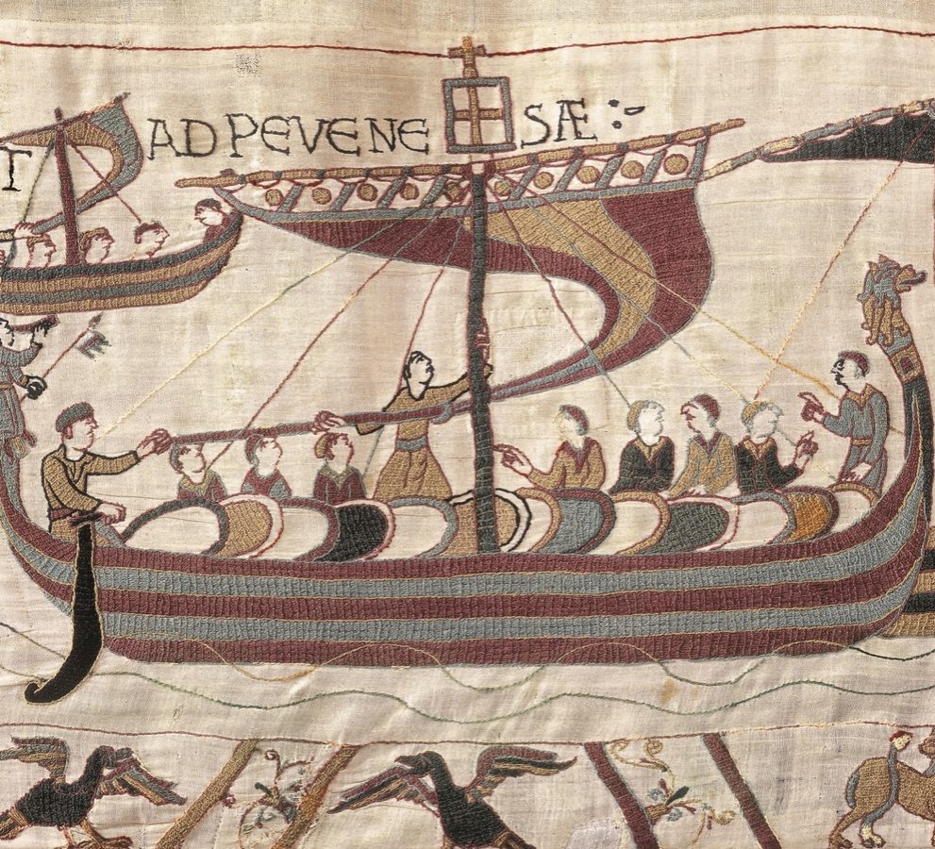
Details of the source:
Section of the Bayeux Tapestry made after 1067. Currently on display at Bayeux in France. This shows William of Normandy, descendent of King Rollo, invading England. The Bayeux Tapestry was probably commissioned by Bishop Odo of Bayeux, half-brother of William of Normandy, probably in the 1070’s.
Historical question to be answered:
What can the Bayeux Tapestry tell us about the Vikings?
Type
What type of source is it: Primary, secondary, oral, physical, written, personal or combination?
The Bayeux Tapestry is primary source. The Bayeux Tapestry is a physical source which was embroidered on 70 metres of linen, illustrating the Norman conquest of Britain.
Origin
Can you identify who has provided the information on the source or where it has come from (where was the source made and by who)?
The Bayeux Tapestry was made in Normandy, France. It was started somewhere between 1067 -1070, after the Norman conquest of Britain. It was possibly commissioned by Bishop Odo of Bayeux, the half-brother of William of Normandy (or William the Conqueror). Other historians have suggested it may have been commissioned by Queen Edith. It was constructed by Anglo-Saxon women, in England, although historians are unsure exactly where in England it was made.

Motive
Can you determine why the source might have been constructed or why the information has been provided?
As the tapestry shows the Norman conquest of Britain, it was possibly commissioned to glorify the exploits of William the Conqueror. As it was probably commissioned by William’s half-brother, it might have been made to ensure that Bishop Odo was seen as being supportive of William and to gain William’s favour. It may also have been made to demonstrate to other people how mighty and powerful the Norman conquerors were. Especially if people other than the Normans were able to view this tapestry.
Audience
Who do you think is the intended audience for the source?
The tapestry would have been intended to be displayed in a prominent place, possibly in a prominent Norman Castle in Britain. Therefore, the intended audience of the Bayeux Tapestry would have been diverse. It would have been seen by the Norman nobles who resided in, and visited, the castle. It would also have been seen by the Anglo-Saxon people who lived and worked in the castle. People from other places may have visited this castle and they would have also seen the tapestry.
Content
Describe the content of the source in detail. What information/evidence does it provide to help you answer your historical question?
The tapestry contains 58 scenes of the events leading up to and during the Norman conquest of Britain. Each frieze, or panel of the tapestry shows a different event. Some of the individuals shown in the tapestry include Harald Hardrada, who attempted to take control of England at the same time that William the conqueror was attempting to take control.
The tapestry can tell us much about the Vikings. We can see from this tapestry that the Vikings were active in attempting to take control of different areas in Europe during this time, and this had been going on for quite some time. The Normans themselves were direct descendants of Vikings who had seized control of Normandy in France. This shows that Viking control or influence extended far beyond Scandinavia and that they were actively involved in European politics during this period.

Sample PEEL Paragraph

Example - Ivar the Boneless
Describe the importance of your chosen Viking on Viking society.

(Point) Ivar the Boneless was an important Irish Viking who is most well known as a fearless and savage warrior. (Evidence) The Norse Saga’s suggest that one of his most notable battles was with his brother’s, where he led a Viking force on an invasion of England. His Great Heathen Army first conquered York and then quickly moved through the other three kingdoms, pillaging and slaughtering anyone that stood in their way. One of these battles as stated in the saga’s suggests that he (Evidence) ‘captured Ælla and subjected him to death by blood eagle to avenge Ragnar’s death’. (Explanation) This highlights just how aggressive he and his army were when fighting against their enemies. These invasions of England resulted in Viking settlements throughout the area which lasted for the next two hundred years. (Link) Therefore, Ivar the Boneless had an important impact on Viking society due to his ferocious and successful battles leading to permanent settlements in England which lasted for generations.

Primary source – Norse Saga’s
Secondary source - https://www.historic-uk.com/HistoryUK/HistoryofEngland/Great-Heathen-Army/

ASSESSMENT MARKING CRITERIA – TOMAC Analysis – PART A
HT4-8: Locates, selects and organises information from sources to develop an historical inquiry | Grade
The student located, selected and organised information into a completed TOMAC analysis for a primary or a secondary source which is accurate and comprehensive. They have demonstrated an outstanding ability to identify, in detail, the Type, Origin, Motive and Audience of the selected sources. In addition, the student has provided a detailed description of the Content of the source. | A
The student located, selected and organised information into a completed TOMAC analysis for a primary or a secondary source which is accurate and detailed. They have demonstrated the ability to thoroughly identify the Type, Origin, Motive and Audience of the selected sources. In addition, the student has provided a description of the Content of the source. | B
The student located, selected and organised information into a completed TOMAC analysis, for a primary or a secondary source which is completed a TOMAC analysis for a Primary and a Secondary source. They have demonstrated a sound ability to accurately identify the Type, Origin, Motive and Audience of the selected sources, although this may lack detail. In addition, the student has provided a description of the Content of the source. | C
The student has submitted a TOMAC analysis for a primary or a secondary source, but it is incomplete and lacks detail. They have demonstrated a basic ability to identify the Type, Origin, Motive and Audience of the selected sources, although this lacks the necessary detail. In addition, the student has identified some of the Content of the source. | D
The student has submitted a TOMAC analysis for a primary or a secondary source. They have demonstrated a limited ability to identify the Type, Origin, Motive and Audience of the selected sources, and the task lacks detail. The student may have identified some of the Content of the source. | E

ASSESSMENT MARKING CRITERIA – Response – PART B
HT4-6: Uses evidence from sources to support historical narratives and explanations | Grade
The student uses evidence from sources to demonstrate extensive knowledge and understanding of their chosen Viking. The response is comprehensive and clearly describes the importance of their person on society in two or three structured PEEL paragraphs. All work is written in the students’ own words. | A
The student uses evidence from sources to demonstrate a thorough knowledge and understanding of their chosen Viking. The response is detailed and clearly describes the importance of their person on society in two or three structured PEEL paragraphs. All work is written in the students’ own words. | B
The student uses evidence from sources to demonstrate a sound knowledge and understanding of their chosen Viking. The response clearly describes the importance of their person on society in two or three structured PEEL paragraphs. All work is written in the students’ own words. | C
The student may or may not use evidence from sources to demonstrate a basic knowledge and understanding of their chosen Viking. The response describes some of the details about their person, which may follow the PEEL paragraph structure. The work is mostly written in the students’ own words. | D
The student demonstrates an elementary knowledge and understanding of their chosen Viking. The response may have a limited description of the details about their person, which may follow the PEEL paragraph structure. Limited work is written in the students’ own words. | E

TOMAC ANALYSIS SHEET
Place your Source
HERE
Historical question to be answered: Describe what this source can tell us about life in the Viking era.
Type - What type of source is it: Primary, secondary, oral, physical, written, personal or combination?

Origin - Can you identify who has provided the information on the source or where it has come from (where was the source made and by who)?

Motive - Can you determine why the source might have been constructed or why the information has been provided?

Audience - Who do you think is the intended audience for the source?

Content- Describe the content of the source in detail. What information/evidence does it provide to help you answer your historical question?

Erik the Red - Sources
Source 1
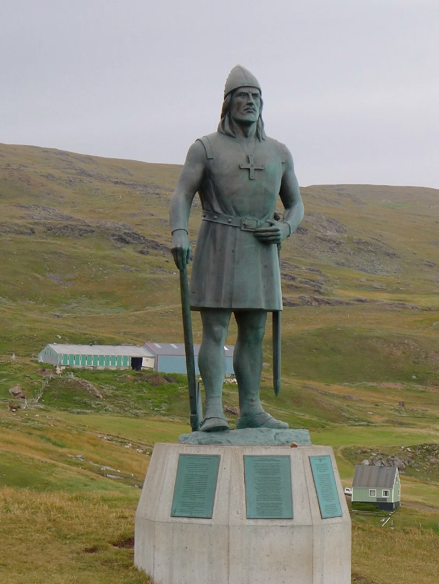
Source Caption: 10-foot replica statue of Eri the Red Statue located in Brattahlid, Greenland. Erected in 2000.
Description: A modern statue of Erik the Red (c. 950-c. 1003 CE) in Greenland, the land where he is credited with forming the first settlement. The statue was erected as a gift on the anniversary of Leid’s voyage as the first European explore American shores as funded by the ‘The Leif Erikson International Foundation’.
Source credit: https://www.worldhistory.org/image/9750/erik-the-red-statue-greenland/ https://www.leiferikson.org/Greenland.htm

Source 2:
Eirik and his people were outlawed at Thorsnes Thing. He prepared a ship in Eiriksvagr (creek), and Eyjolf concealed him in Dimunarvagr while Thorgest and his people sought him among the islands. Eirik said to his people that he purposed to seek for the land which Gunnbjorn, the son of Ulf the Crow, saw when he was driven westwards over the ocean, and discovered Gunnbjarnarsker (Gunnbjorn's rock or skerry). He promised that he would return to visit his friends if he found the land. Thorbjorn, and Eyjolf, and Styr accompanied Eirik beyond the islands. They separated in the most friendly manner, Eirik saying that he would be of the like assistance to them, if he should be able so to be, and they should happen to need him.

Source caption: The Saga of Erik the Red, Chapter 2.
Description: 1880 translation into English by J. Sephton from the original Icelandic 'Eiríks saga rauða'.
Source credit: https://www.tripsavvy.com/l-anse-aux-meadows-national-historic-site-4051762

Leif Eriksson - Sources
Source 1
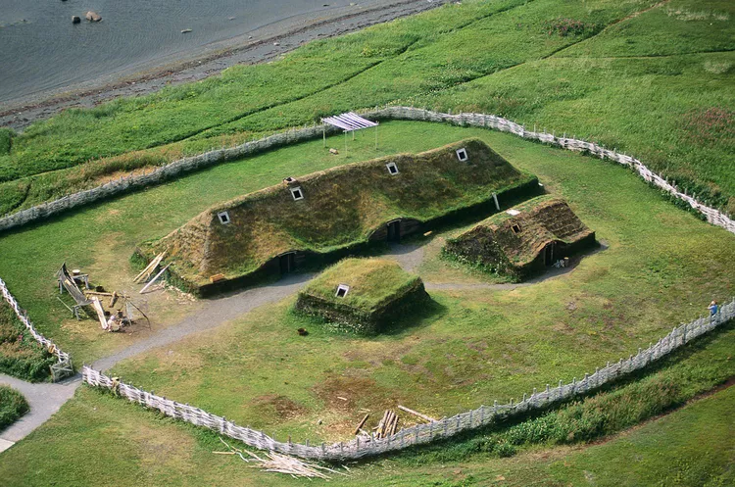Source Caption: L’Anse Aux Meadows
Description: The Norse settlers weren't the only people to find L'Anse aux Meadows a good place to live and fish. Native People first settled here around 3950 B. C. Leifr Eiriksson (Leif Ericsson) and his band of Norse settlers was latecomers to L'Anse aux Meadows, arriving here around 1000 A. D.
Source credit: https://www.tripsavvy.com/l-anse-aux-meadows-national-historic-site-4051762

Source 2
The Saga of Leif Eriksson, Chapter 5 -
‘He joined the body-guard of King Olaf Tryggvason, and the king formed an excellent opinion of him, and it appeared to him that Leif was a well-bred man. Once upon a time the king entered into conversation with Leif, and asked him, "Dost thou purpose sailing to Greenland in summer?"

Leif answered, "I should wish so to do, if it is your will." The king replied, "I think it may well be so; thou shalt go my errand, and preach Christianity in Greenland."

Leif said that he was willing to undertake it, but that, for himself, he considered that message a difficult one to proclaim in Greenland. But the king said that he knew no man who was better fitted for the work than he. "And thou shalt carry," said he, "good luck with thee in it." "That can only be," said Leif, "if I carry yours with me."

Leif set sail as soon as he was ready. He was tossed about a long time out at sea, and lighted upon lands of which before he had no expectation. There were fields of wild wheat, and the vine-tree in full growth. There were also the trees which were called maples; and they gathered of all this certain tokens; some trunks so large that they were used in house-building. Leif came upon men who had been shipwrecked, and took them home with him, and gave them sustenance during the winter. Thus did he show his great munificence and his graciousness when he brought Christianity to the land, and saved the shipwrecked crew. He was called Leif the Lucky.’

Source Caption: The Saga of Erik the Red

Description: 1880 translation into English by J. Sephton from the original Icelandic 'Eiríks saga rauða'.

Source credit: https://sagadb.org/eiriks_saga_rauda.en

